Homework Sheet 11th - 15th May 2020

Monday: 11th May  Rhyme: The little Turtle/ Bhac, Bhac!  Bua na Cainte-pg 19 An Frog agus an Ghé. Recording is above.  Over the Moon Skills Book – pg 111 Ex A (number the boxes and colour)  Dictation 2- See Ms Corkery’s video…watch out for Thanos!  Reading- Book 1 “Starting School” See link below to play it  Just Handwriting- pg 31. The letter “b”-parent uses “Help Please” laminated sheet in folder.  New Handwriting Copy- “man in a jet” 3 lines  Busy at Maths (thick book) Next 2 pages wherever you child is. This varies and it is done in school.  Tricky Words: me,we,be Revise ( the, he, she, I, are, go)  Sight Words: said, to, he. Revise (I- we -me -the-was -she) | Tuesday:  Rhyme/Song: The little Turtle/ Bhac, Bhac!  Over the Moon Skills Book – pg 111 read sentences and write them into the spaces.  Bua na Cainte-pg 18 oral work video above.  Dictation 3- See Ms Corkery’s video with other special guest appearances!  Reading- Book 1 “Starting school”. See link below to play it  What a Wonderful World-pg 43+45  New Handwriting Copy- “man in a jet” 4 lines. This should complete the page and draw the picture!  Tricky Words: me,we,be Revise ( the, he, she, I, are, go)  Sight Words: said, to, he. Revise (I- we -me -the-was -she)  Story Time! “The Bear and the Piano”. Chill out and listen to me! Link below on this page  Add in your own sound effects if you like!  Art- Egg carton flowers- see photo above or Bear stencil.
Wednesday  Rhyme The little Turtle/Bhac! Bhac!  Bua na Cainte-An bhfuil cead agam dul amach? Tá/Níl. (May I go out? No, it’s raining /Yes, it is dry.  Over the Moon Skills Book – pg 110 Ex B  Dictation 4- See Ms Corkery’s video with Captain  America!  Just Handwriting- pg 31. The letter “p”-parent uses “Help Please” laminated sheet  Reading-Book 1 “Starting School”. See link below to play it  Busy at Maths (thick book) next 2 pages  Tricky words I, are, go and Sight Words  “the”, “was” and “she”- revise | Thursday  Rhyme/Song: The little Turtle / Bhac! Bhac!  Maths- pg 33+34 (thin book) Write the days  Grow in Love-pg 42+43  Busy at Maths (thick book) next 2 pages  Reading- Book 1 “Starting School”. See link below to play it  PE/ -Go Noodle -Trolls.. Can’t stop this Feeling!  https://www.youtube.com/watch?v=KhfkYzUwYFk
Thanks to parents for the photos and work sent in. It is nice for them to see familiar faces, I’m sure they miss each other so much. Artwork- I’m trying to stick to household materials for parents’ convenience. Don’t forget to dance with them, these are the things they remember! Stay safe everyone!
“The Bear and the Piano” https://drive.google.com/file/d/1omTMY4MdFWmiLpXuVfopyF25_E6cuEJJ/view?ts=5eb54191
Clíona Corkery 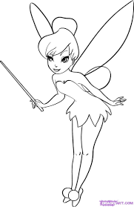
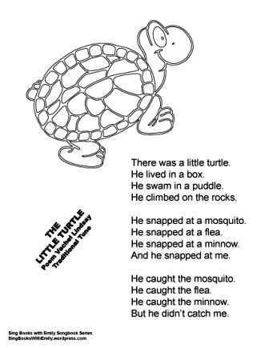  https://www.youtube.com/watch?v=gScCxYHc7Bk | A haon, a dó, a trí,  Frog mór ramhar ina shuí  Trí, ceithair, cúig, sé,  Hata beag bídeach ar an ngé  Bhac bhac (recording above)  Bhac, bhac, arsa an lacha  Tá an lá fluich  Bhac! bhac! arsa an lacha  Tar amach, tar amach  Bhuf bhuf arsa an madra,  Tá an lá fluich,  Wuf wuf arsa an madra,  Téigh isteach, téigh isteach

Readers!
This is the link for Book 1 “Starting School”
https://content.yudu.com/web/1yssw/0A224cw/OTMJnrInfsFReader1/html/index.html?refUrl=https%253A%252F%252Fwww.gillexplore.ie%252Fgill-explore-resources%252Fover-the-moon-junior-infants-skills-book%253FChapters%253D0%2526ResourceTypes%253D11302
The readers in your child’s folder are a mix of types of books available in the programme.
Genre, Fiction and Non-Fiction. The books I put on the homework sheet to date are genre books. Apologies… I think I said the first 3 readers were in their folders, not the case! Only online. The next 9 readers are actually, in their folders! These are modelling how to read. They are more difficult.
I have 3 more dictation videos this week. The whole alphabet will be revised then- the sound, name, song and shape of each letter.
I thought it was easier to revise everything through video first, rather than the parents trying to piece it all together. The next 3 dictations have toys in them, so they are not as boring!! They should be well able to handle and deal with the material then.

Grow in Love website is www.growinlove.ie/en. The log in is trial@growinlove.ie.password is growinlove

