Homework Sheet 2nd -5th June 2020 – 3 links under the poems for you.Enjoy!!

BANK  HOLIDAY | Tuesday 2nd June  Rhyme: June is a Tune/ Nigh na héadaí  Bua na Cainte- pg 25 Tá an hata/léine/geansaí salach (the hat/shirt/jumper is dirty. Video 1.above.  Over the Moon Skills Book – pg 116 Ex (A+B)  Dictation - See Ms Corkery’s video. Link is under poems. We are now on sentences!  Reading- Book 4 “Toys” See link below to play it  Just Handwriting- pg 32. The letter “v”-parent uses “Help Please” laminated sheet in folder.  New Handwriting Copy- “dog at the vet” 3 lines  Busy at Maths (thick book) Next 2 pages wherever you child is. This varies and it is done in school.  Tricky Words: : Fancy coming to Ms Corkery’s Funfair for a few minutes? Come – some – said Revise( was-to-do –me- we- be-the- he- she- I- are- go)  Sight Words: Fancy coming to Ms Corkery’s Funfair for a few minutes? you – your - come Revise ( all-do-they -he- be- are said – to – he- I - we -me –the –was –she)  Art- fish bought at the pet shop-See above.
Wednesday:  Rhyme/Song: June is a Tune/ Nigh na héadaí  Over the Moon Skills Book – pg 116 Ex C .  Bua na Cainte- pg 26 Cé leis an hata/bríste/gúna? (who owns the hat/pants/dress? See video 2.  Dictation Call out this sentence . Copy my Monday video parents! “The sun is out.”  Reading- Book 4 “Toys”. See link below to play it  What a Wonderful World-pg 16+17  New Handwriting Copy- “dog at the vet” 4 lines. This should complete the page and draw the picture!  Tricky Words: Come – some – said Revise (was-to-do –me- we- be-the- he- she- I- are- go)  Sight Words: Replay Ms Corkery’s video. Press mute so they can call out the words themselves. you – your - come Revise ( all- do- they - he- be- are - said – to – I - we -me – the –was – she)  Story time! /Art. Watch the story of this week… Link is under poems. | Thursday  Rhyme: June is a Tune/ Nigh na héadaí  Maths- pg 39+40 (thin book)  Bua na Cainte-pg 27 colour while listening to the story-Video 3.  Bhi an geansaí salach- the jumper was dirty  Nigh Teidí an geansaí-Teddy washed the jumper  Bhí an geansaí glan- the jumper was clean  Chroch Teidí amach an geansaí- Teddy hung out the jumper to dry.  Over the Moon Skills Book – pg 117 Ex B (NOT Ex A yet!)  Dictation :Call out the sentence “ The grass is wet.”  Just Handwriting- pg 32. The letter “w”-parent uses “Help Please” laminated sheet  Reading-Book 4 “Toys”. See link below to play it  Busy at Maths (thick book) next 2 pages  Tricky Words: Come – some – said Revise ( was-to-do –me- we- be-the- he- she- I- are- go)  Sight Words: you – your - come Revise ( all-do-they -he- be- are said –to – he- I - we -me –the –was –she)  PE-https://www.youtube.com/watch?v=ymigWt5TOV8
Hope you all enjoyed the rest. Just do what you can everyone. Take care!
Clíona Corkery
3 links connected to the homework this week - See coloured hmk sheet
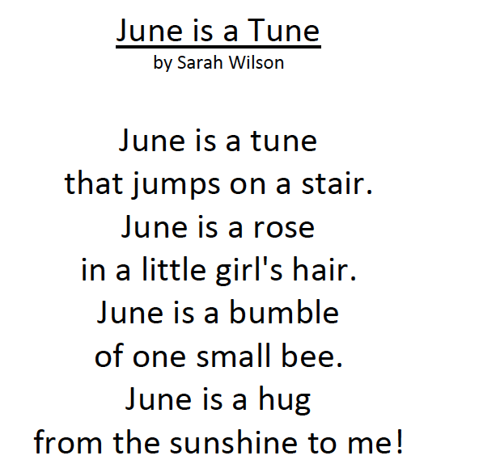 | Nigh na hÉadaí (video 4)  Nigh na hÉadaí  Nigh na hÉadaí  Nigh is nigh is nigh na hÉadaí  Croch amach na hÉadaí  Croch amach na hÉadaí  Croch amach is croch amach is Croch amach na hÉadaí

Readers!
This is the link for Book 4 “Toys” (Non Fiction pre reader)

