Wellness week! 3 links under poems
Monday: 25th May  Rhyme:Sun Sal / Cuir ort do chóta-Bain díot do chóta  Bua na Cainte-.cuir ort chóta ( put on your coat)  Video 1 (Oral work only)  Story time! Watch the story of this week. Link is under poems  Over the Moon Skills Book – pg 114. Based on Story time  Wellness journal See attached above PDF. This is optional if you don’t have a printer  Dictation - See Ms Corkery’s video CVC words. - Help her break a spell put on someone! Link is under poems.  Reading- Book 3 “Ella in Hospital” See link below to play it. New words are dog-fit-get-on-up-leg-fit-bat  Just Handwriting- pg 32. The letter “j”-parent uses “Help Please” laminated sheet in folder.  New Handwriting Copy- “pig in the mud” 3 lines  .  Tricky Words: all-you-your Revise ( was-to-do me, we, be, the, he, she, I, are, go) Interactive games with the reader book 3, this week.  Sight Words: all-do-they See Ms Corkery’s Games video Revise ( he-be-are said –to – he-I- we -me -the-was -she  Art- Draw a simple Chameleon see above. | Tuesday:  Rhyme: Song:Sun Sal /Cuir ort do chóta-Bain díot do chóta  Bua na Cainte - Eadaí (clothes). Taispeáin dom (show me) cóta-hata-scairf-bríste-bróga-stocaí  Video 2 (Oral work only)  Over the Moon Skills Book – pg 114 Ex A (real or nonsense words) colour in real ones  Dictation : Call out words …sap, sip, ram. Copy my Monday video parents!  Reading- Book 3 “Ella in Hospital” See link below to play it.  New words are dog-fit-get-on-up-leg-fit-bat  What a Wonderful World-pg 46 (sound) +pg 30 (wind)  New Handwriting Copy- “pig in the mud” 4 lines. This should complete the page and draw the picture!  Tricky Words: all-you-your Revise( was-to-do me, we, be, the, he, she, I, are, go) Interactive games with the reader book 3, this week  Sight Words: all-do-they Revise ( he-be-are said –to – he-I- we -me -the-was -she  PE/ -Go Noodle –Syllable Dance  https://www.youtube.com/watch?v=psUPYR235O8  Wellness Journal See attached above PDF. This is optional if you don’t have a printer
Wednesday  Rhyme: Sun Sal / Bain díot do chóta  Bua na Cainte- Bain díot do chóta-hata-scairf-bhróga-stocaí. Video 3 (Oral work only)  Over the Moon Skills Book – pg 116 Ex A (only)  Dictation : Call out the words tin,trap,fit  Just Handwriting- pg 32. The letter “v”-parent uses “Help Please” laminated sheet  Reading- Book 3 “Ella in Hospital” See link below to play it. New words are dog-fit-get-on-up-leg-fit-bat  Tricky Words: all-you-your Revise( was-to-do me, we, be, the, he, she, I, are, go)  Sight Words: all-do-they See Ms Corkery’s video Revise ( he-be-are said –to – he-I- we -me -the-was –she. Interactive games with the reader book 3, this week. | Thursday  Rhyme/Song: Sun Sal/ Cuir ort do chóta-Bain díot do chóta  Reading- Book 3 “Ella in Hospital” See link below to play it. New words are dog-fit-get-on-up-leg-fit-bat  Dictation: Call out the words –Wag, bun, band- Copy my Monday video parents.  Busy at Maths- pg 37+38 (thin book)  Grow in Love-pg 46+47  Tricky Words: all-you-your Revise( was-to-do me, we, be, the, he, she, I, are, go) Interactive games with the reader book 3, this week  Sight Words: all-do-they See Ms Corkery’s video Revise ( he-be-are said –to – he-I- we -me -the-was –she  Wellness journal See attached above PDF-optional
- Sun Sal Poem-yoga for Kids  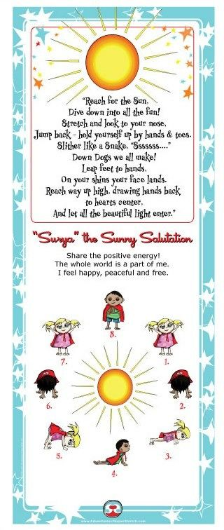 | Cuir ort do chóta/Bain díot do chota (see video 4.)  Cuir ort do chóta, (put on your hat)  Cuir ort do chóta,  Cuir ort do chóta,mar  Tá an lá fuar  Cuir ort do hata,(take off your hat)  Cuir ort do hata,  Cuir ort do hata,mar  Tá an lá fluich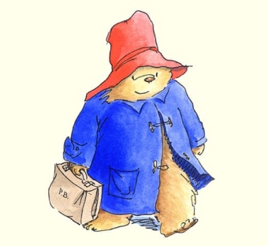  Bain díot do chóta,(take off your coat)  Bain díot do chóta,  Bain díot do chóta,  Mar tá an lá té.  Bain díot do hata (take off your hat)  Bain díot do hata  Bain díot do hata  Mar tá an lá tirim
3 links connected to the homework this week
*Storytime
https://drive.google.com/open?id=1Ai4YG6Ub7aooja5eRC8n2uc54XMEjO4d
*Dictation
https://drive.google.com/file/d/1c9Sq-0V-FFlztdQ3R7OHP55o9idAFYHE/view?ts=5ec57fa6
* Ms Corkery’s Games of Sight Words/Tricky Words
https://drive.google.com/file/d/1o-Wge7Um0nCUL6NKXKW3B4cZUBgqviYD/view?usp=sharing
.
Readers!
This is the link for Book 3 “Ella in Hospital” (Fiction)
https://content.yudu.com/web/1yssw/0A224cw/OTMJnrInfsFReader3/html/index.html?refUrl=https%253A%252F%252Fwww.gillexplore.ie%252Fgill-explore-resources%252Fover-the-moon-junior-infants-skills-book%253FChapters%253D0%2526ResourceTypes%253D11302
This below is a link to an interactive games of “Ella in Hospital”- Odd One Out game, Balloon Pop (Sight words) game etc. There are 6 games.
https://www.gillexplore.ie/gill-explore-resources/over-the-moon-junior-infants-skills-book?Chapters=0&ResourceTypes=11535-
**Click on Unit 3. Hospital theme.
This is the link for Book 2 “The Farm” (Non Fiction pre reader)
https://content.yudu.com/web/1yssw/0A224cw/OTMJnrInfsNfReader2/html/index.html?page=2&origin=reader
This below is a link to an interactive games of the farm
https://www.gillexplore.ie/gill-explore-resources/over-the-moon-junior-infants-skills-book?Chapters=0&ResourceTypes=11535.. Then choose Unit 2!
This is the link for Book 1 “Starting School”(Fiction)
https://content.yudu.com/web/1yssw/0A224cw/OTMJnrInfsFReader1/html/index.html?refUrl=https%253A%252F%252Fwww.gillexplore.ie%252Fgill-explore-resources%252Fover-the-moon-junior-infants-skills-book%253FChapters%253D0%2526ResourceTypes%253D11302

