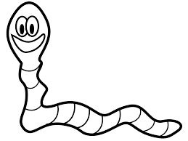
Ooey Gooey

Oooey Gooey was a worm
And a mighty worm was he
He sat upon a railroad trac k
And a train he did not see,
Oooey Gooey!

Draw a picture of the train and Ooey Gooey
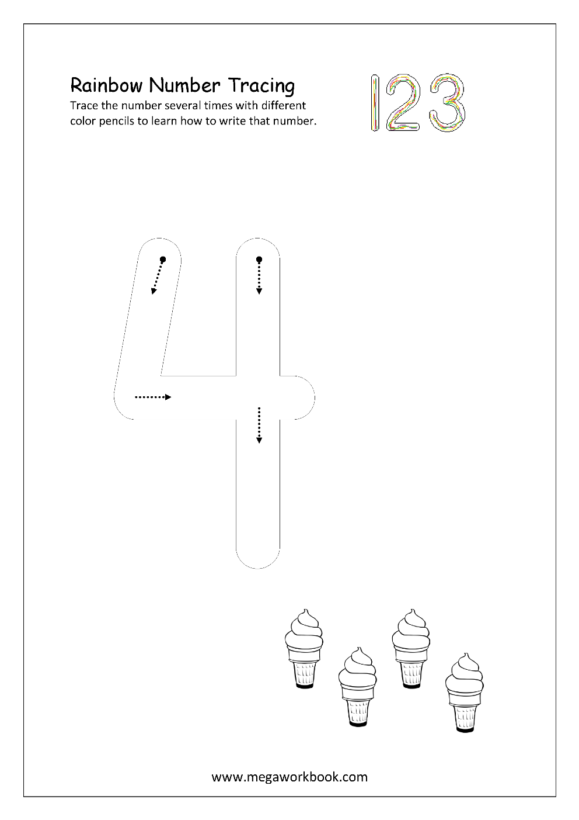
Monday
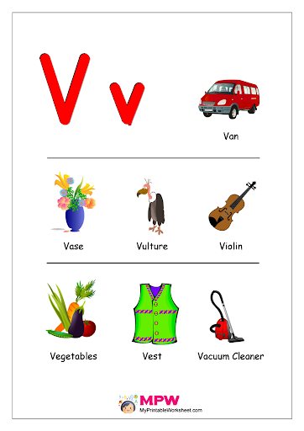
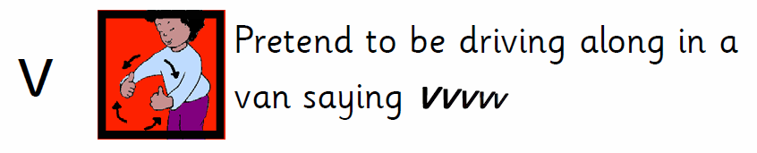
Tuesday
Practice correct letter formation. Remember to encourage correct grip.

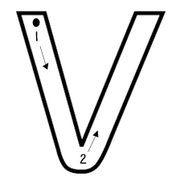

Practice with finger first.
Start at the top.
Slide down and up the hill.

Practice in the air, on tables, on windows, etc.

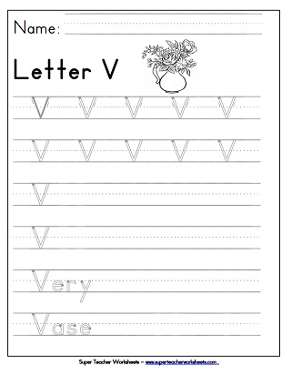
Wednesday
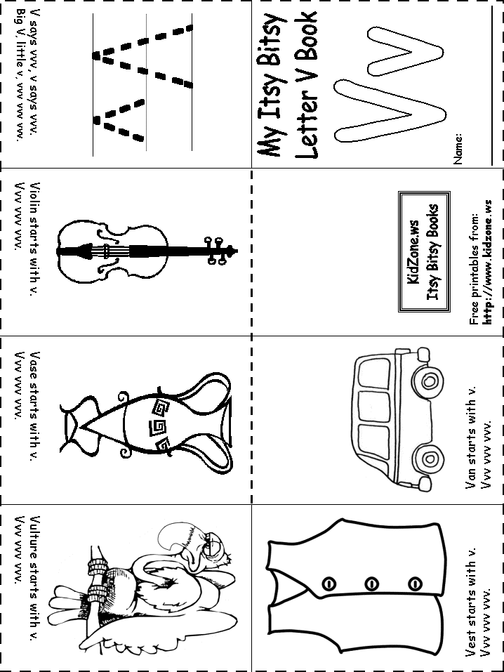
Tricky Words Week 3

she
me
we

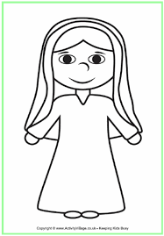
May is the Month of Mary.

Mary had a son called Jesus. Yes / No
Mary was married to Fred. Yes / No
We celebrate Mary at Easter time. Yes / No
Mary was sad when Jesus died. Yes / No
My Family Tree - Draw pictures of your family members on leaves. Include your sisters, brother, parents, grandparents and yourself . Use family tree and leaves template here or make your own.

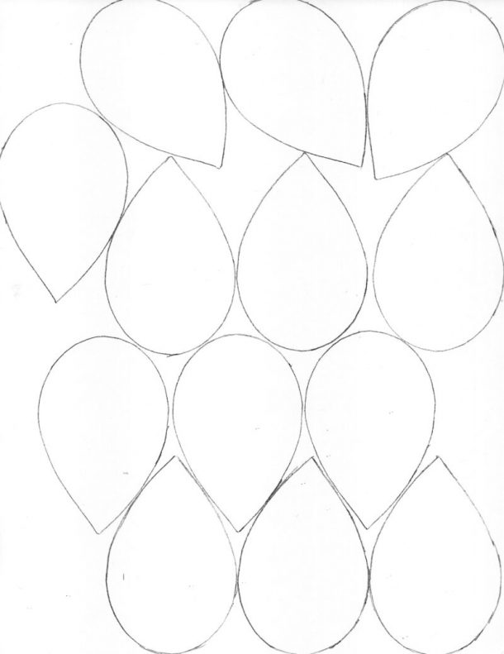

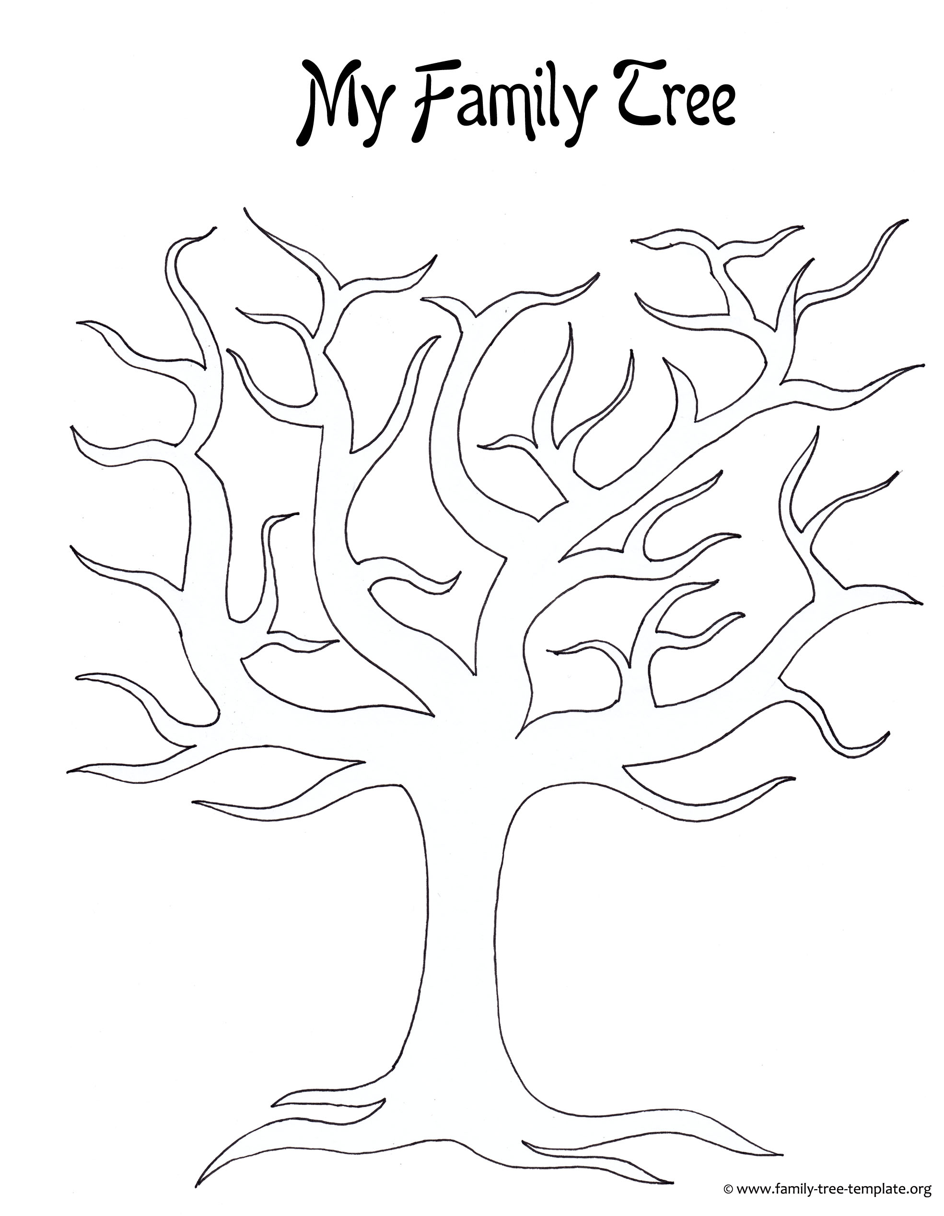
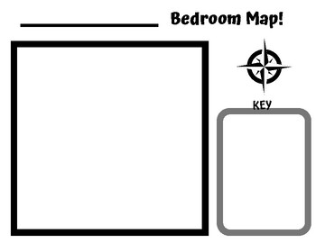
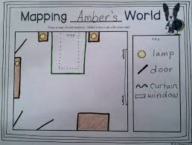
Draw the bed, wardrobe and one more piece of furniture on your map. Here is an example.

