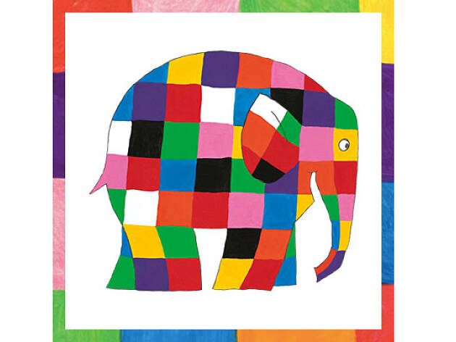
Elmer

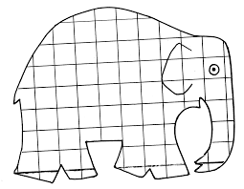
Colour in this Elmer or draw your own

Maths
Capacity
*Vocabulary to use: full, empty, holds more/less, nearly empty/full, nearly as much, container, jug.

Every day pick a practical activity to do from this list of ideas: Filling and emptying different containers with water/ sand/dirt/wood chips/pebbles/pasta/rice, etc. Use all kinds of household items to measure e.g. teaspoons/table spoons/baby formula/porridge scoops/small plastic cups, etc. Discuss how many spoons it took to fill the small flowerpot/mug, etc. Le t them come up with things to fill and empty.

Tuesday
http://data.cjfallon.ie/resources/19596/activity-96/index.html

http://data.cjfallon.ie/resources/19596/activity-96/index2.html

Wednesday

http://data.cjfallon.ie/resources/19596/activity-97/index.html

http://data.cjfallon.ie/resources/19596/activity-97/index2.html

Thursday

http://data.cjfallon.ie/resources/19596/activity-98/index.html

http://data.cjfallon.ie/resources/19596/activity-98/index2.html

Friday

http://data.cjfallon.ie/resources/19602/activity-115/index2.html

http://data.cjfallon.ie/resources/19602/activity-115/index2.html#

