Penguin by Polly Dunbar
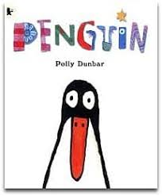

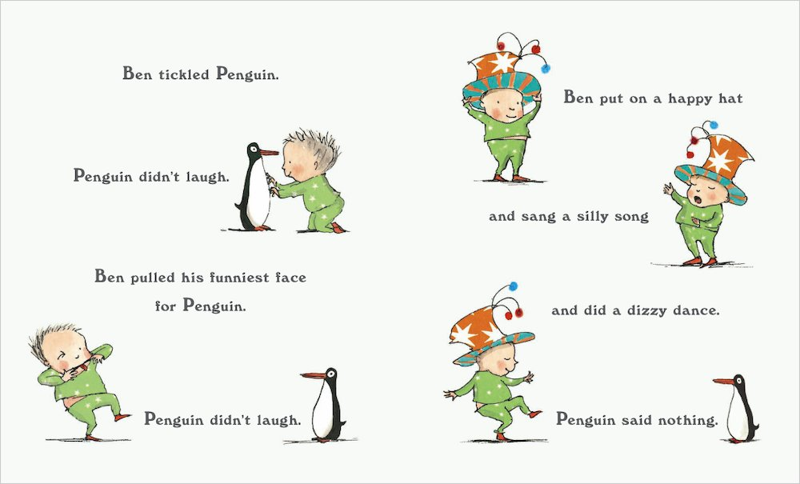

Examples of sentences:
The Lion is blue.
Penguin is small
Ben is sad.
Ben has a happy hat.
Maths
Number: Before and After

Vocabulary to use: what comes before/between and after.

Activity 1
Make your own large number line from 0 to 5. Using a small piece of paper, block a number, what comes before 3, after 4, between 3 and 5, etc.
*Do 5 sums orally daily.

Activity 2
You can use worksheets provided below or write out numbers in a copy like this using your homemade number line:

1 |  | 3
 | 4 | 5
 | 1 | 2

*Write out 5 sums daily.

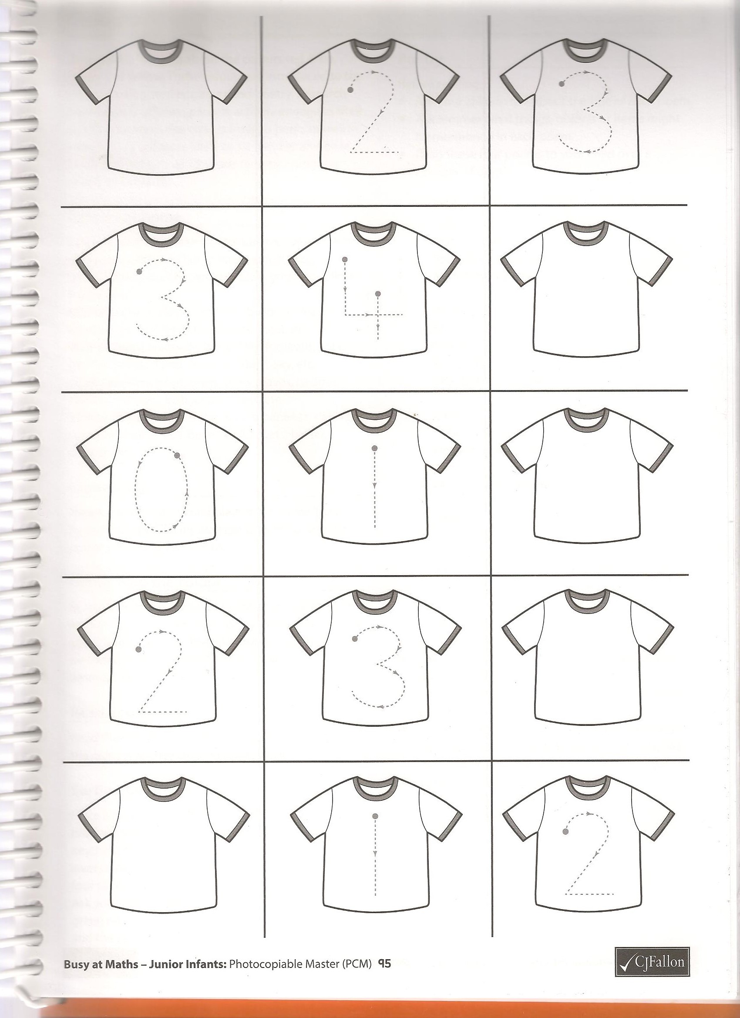
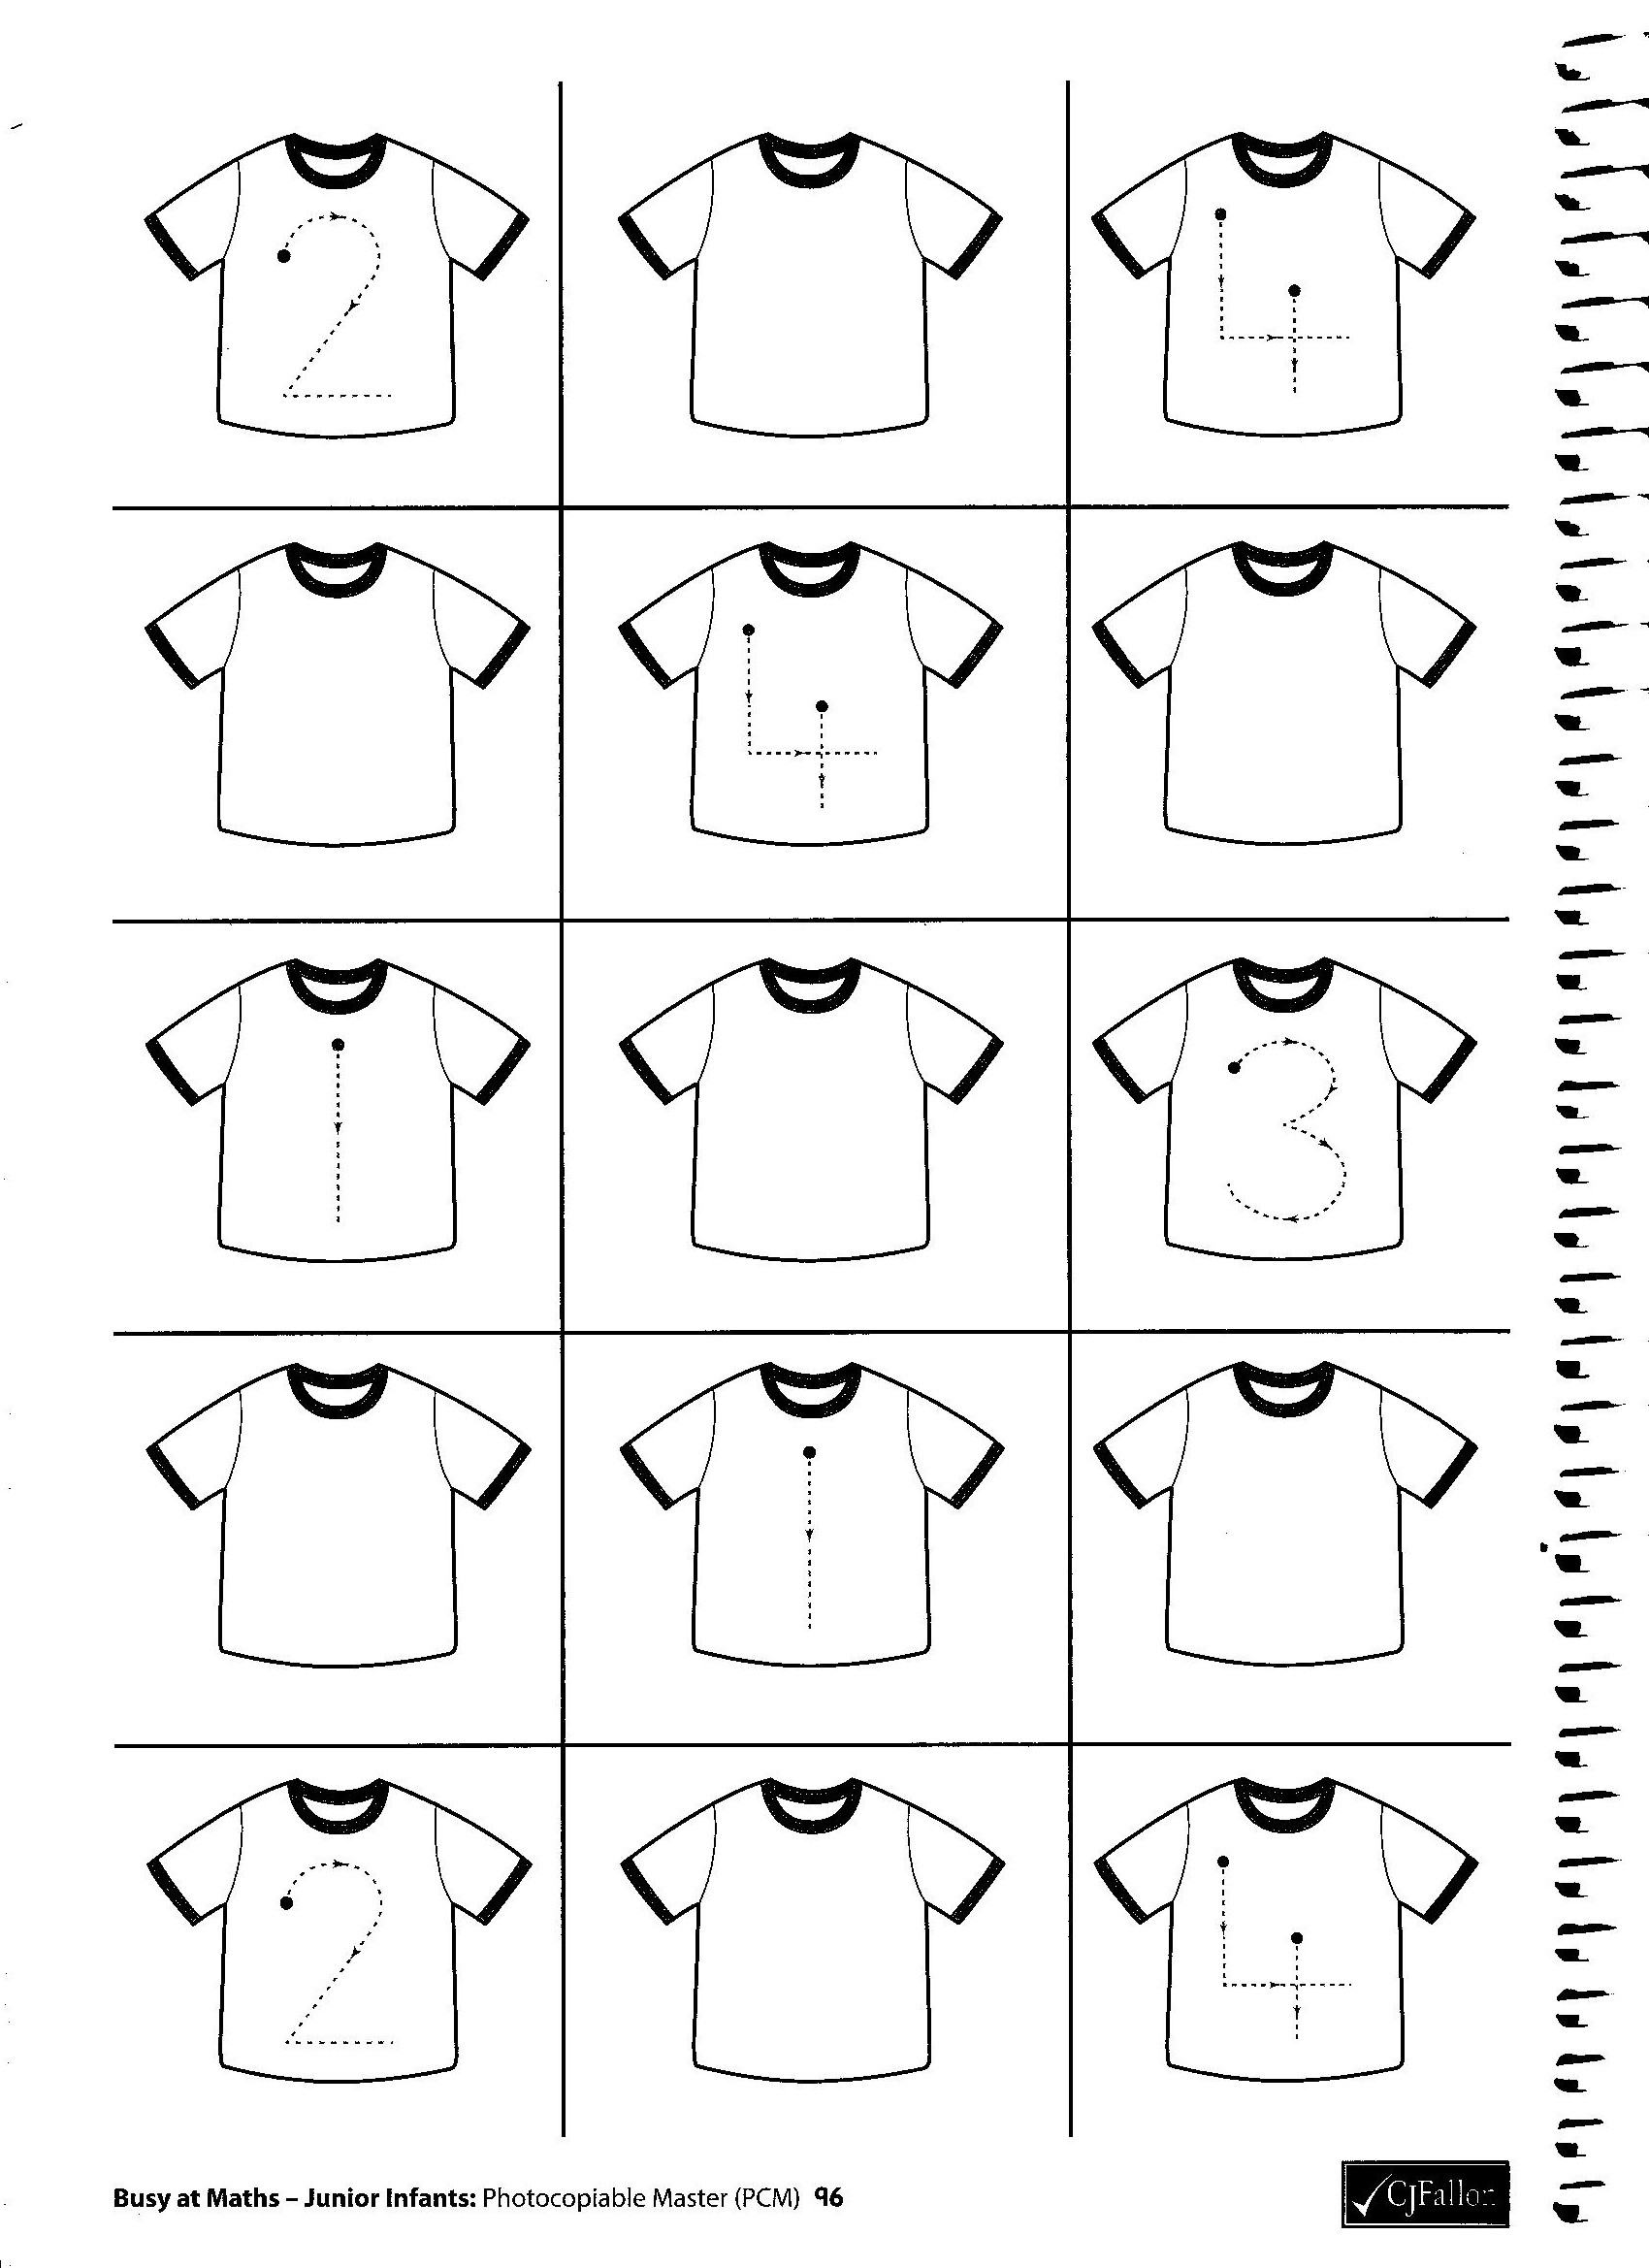
The Lion Inside by Rachel Bright
