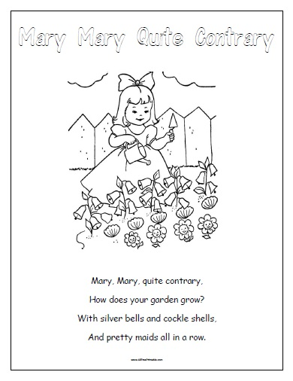
Poem

Ordinal Numbers Activities

1. Line It Up - You can use stuffed animals, lego, cars, trains, or any other objects that interest your child. Use 3 objects and number cards. Let your child point to the object and match the correct number card. You can make your own number cards or print off these ones. You can make this more difficult by adding more objects to the line. E.g. 4th,5th,6th .
2. Mix up number cards to make sure your child can identify 1st, 2nd, 3rd.
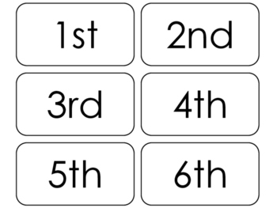
3. Use Twinkl sheets to practice further.
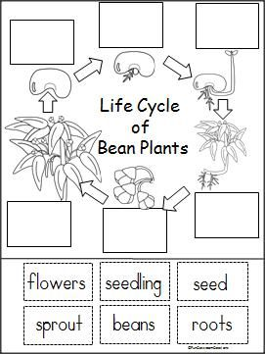
Science

Copy or print off and fill in to complete life cycle of a bean plant
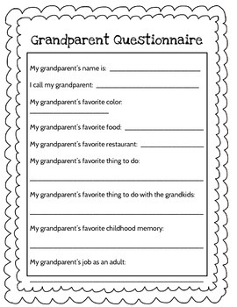
History
An adult can help with the writing. The main aim is for the child to ask the questions.
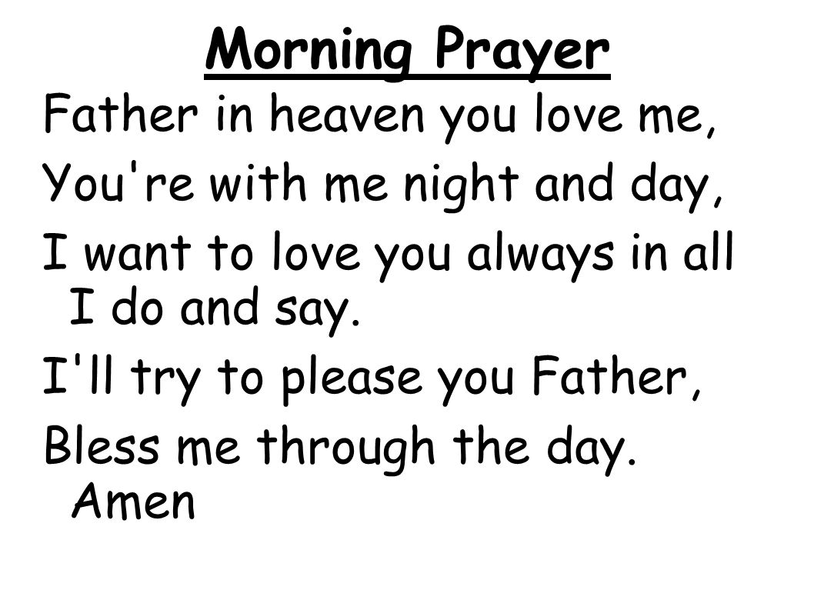
Draw a picture of yourself praying.

Geography
My Journey to the Shop
Home
Shop
Draw a picture of your home and 4 things you see on your way to the shop. Label your pictures.
Examples you could use: bus stop, traffic lights, a friend’s house, a bridge, Blarney Castle, etc.

