**ZOG**

**By**

**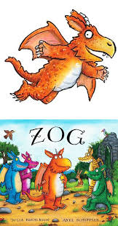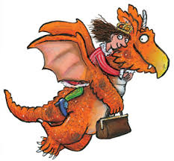 Julia Donaldson**

**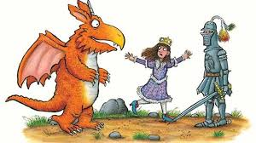**

**Examples of Sentences:**

**Zog is orange.**

**Princess Pearl is helpful.**

**Dragons are scary.**

**Zog can breathe fire.**

**Gordon’s Great Escape**

**By**

**Sue Hendra**

**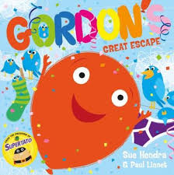**

**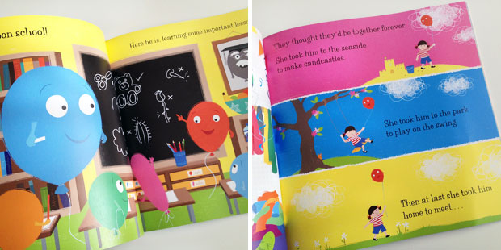**

**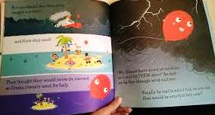**

**Maths Scavenger Hunts**

***Monday:* Find 3 of each 2D (circle, square, rectangle & triangle) shape in your home/ toy box. Lay out as in picture**

**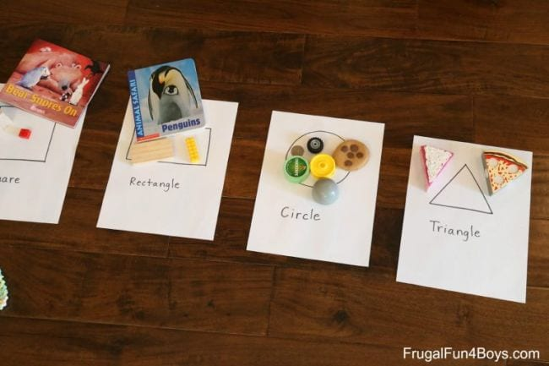**

***Tuesday:* Find 3 of each 3D (sphere, cube, cuboid, cylinder) shape in your home/ toy box**

***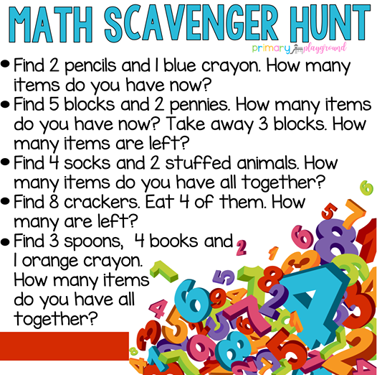Wednesday:***

***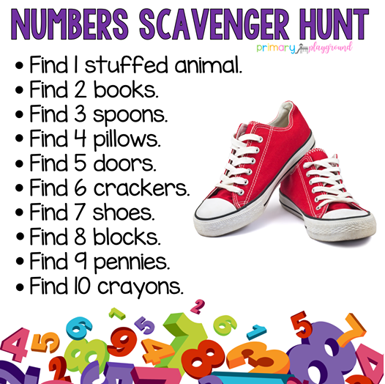Thursday:***

**Digraph Bingo**

**Make your own (9 pictures) or print off boards below.**

**Play bingo 4 times (there are 4 boards per page)**

|  |  |  |  |  |
| --- | --- | --- | --- | --- |
| **ai** | **ng** | **oa** | **ie** | **ou** |
| **er** | **oo** | **ee** | **ar** | **or** |
| **th** | **sh** | **ch** |

**Bingo Sheet 1**

|  |  |  |  |  |
| --- | --- | --- | --- | --- |
| horse |  |  | snail | igloo |
|  | sandwich |  |  |
|  |  |  | **MCj04078560000[1]** |

|  |  |  |  |  |
| --- | --- | --- | --- | --- |
| rainbow | flower |  | tree | goat |
| wellies |  | swing | horse |
| [http://www.mr-sheep.com/main_images/sheep.jpeg](http://www.mr-sheep.com/galleries.htm) |  |  | sl00636_ |

**Bingo Sheet 2**

|  |  |  |  |  |
| --- | --- | --- | --- | --- |
| orange |  |  | mushrms | leaves |
|  | http://www.surplusandoutdoors.com/ishop/images/877/AIRWAIR-SHOE-MA24A.jpg |  |  |
| **MCj04338560000[1]** |  | sandwich |  |

|  |  |  |  |  |
| --- | --- | --- | --- | --- |
| AN00424_ | sl00636_ |  | tree | goat |
| bs00995_ |  |  |  |
|  | leaves |  |  |