Pirate Rhyme

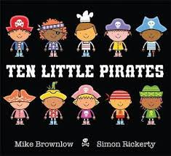

10 Little Pirates

1 Little, 2 little,

3 little pirates

4 little, 5 little

6 little pirates

7 little, 8 little,

9 little pirates
10 LITTLE PIRATES!

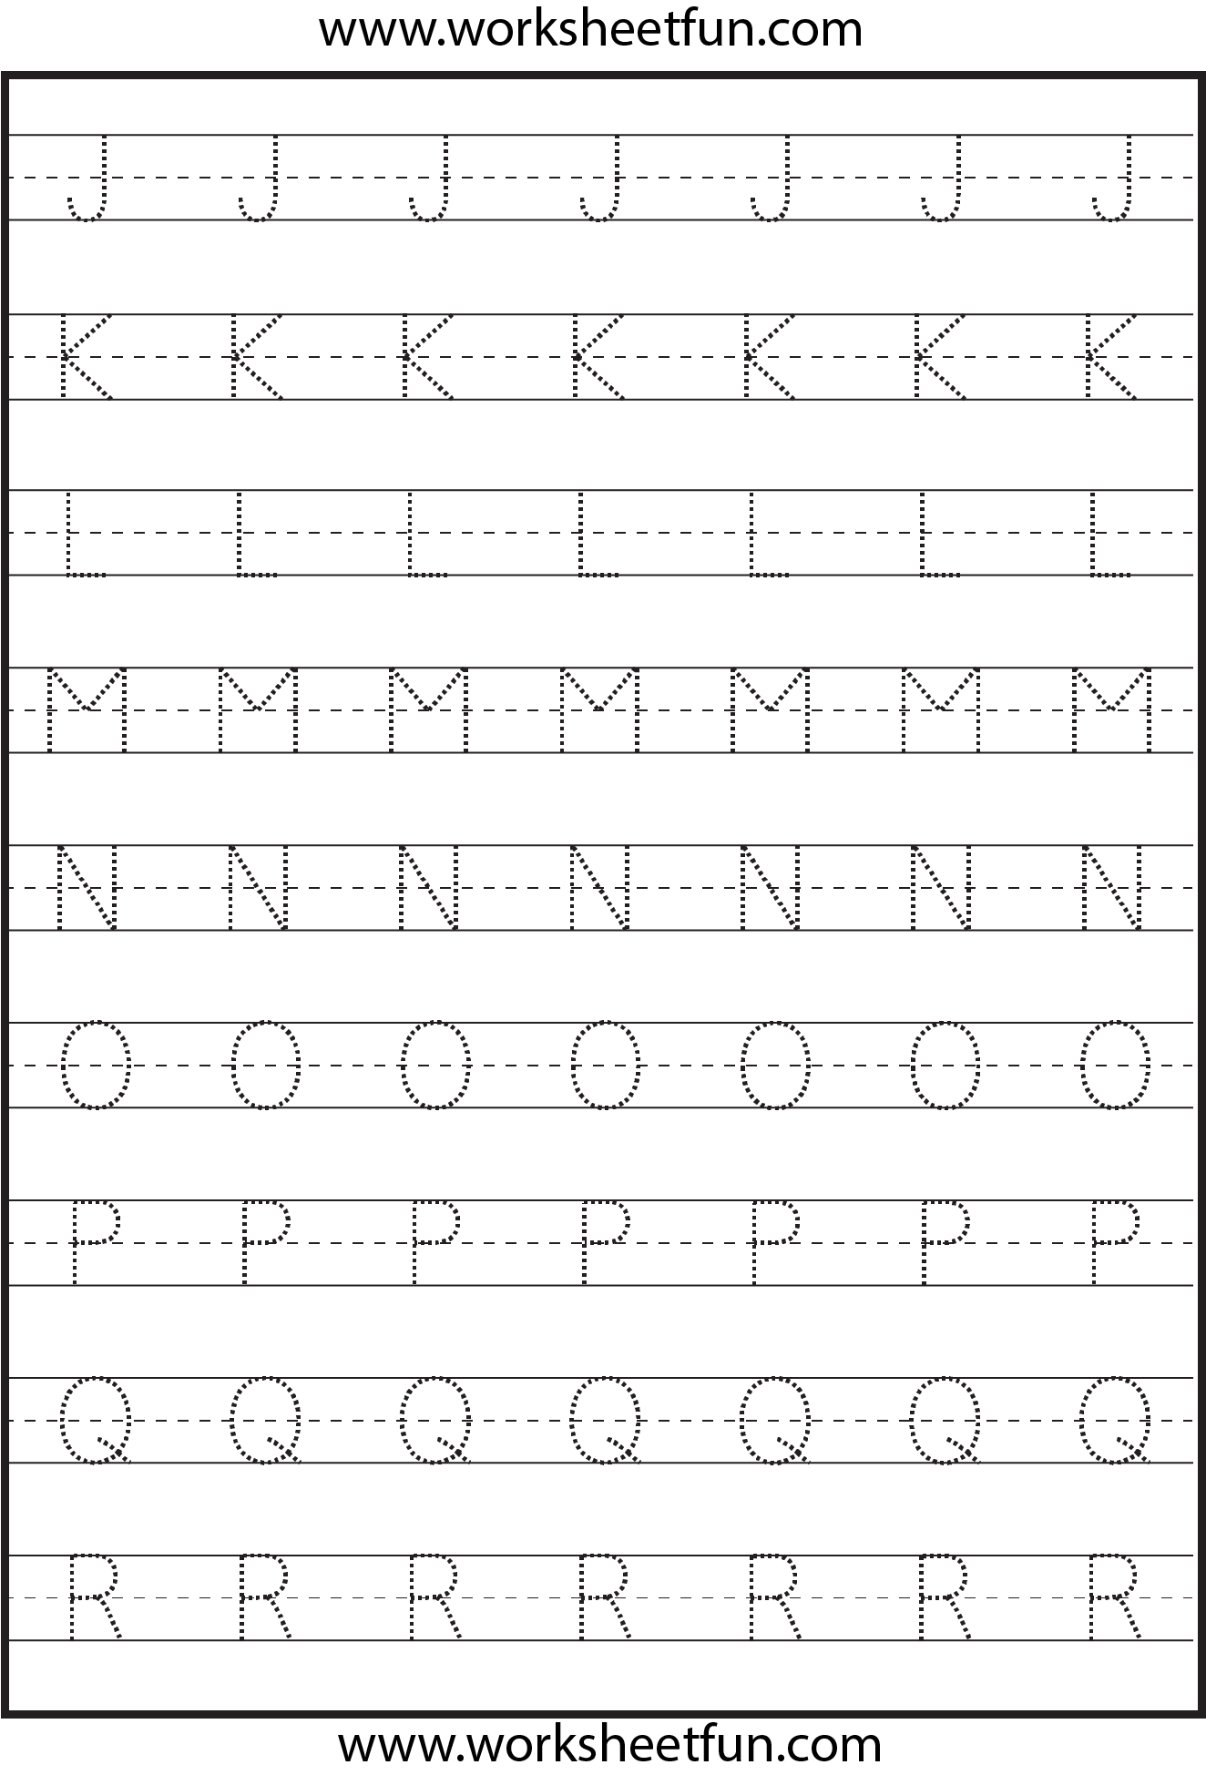

Pirate Treasure

Language: coin, 1 / 2 / 5 cent, euro, price, cost, buy, sell, spend, spent, pay
Pick from these activities using real coins. Remember when making sums put the ‘c’ symbol after number – 1c.
Treasure chest
- Using any box, fill with plenty of 1 and 2 cent coins. Child takes out a coin at a time until you say stop. They count the number of coins and record in a copy. Repeat.
- Take 2 coins from treasure chest and make a sum, record in copy.
e.g. 1c +2c = __c, 2c+2c = __c
Filling the Treasure chest
We play this in school. Using a Tupperware tub, drop coins in one at a time and your child counts each time they hear a thud. We play this in school. 4 thuds – 4c

Hungry pirates
Make price tags for some items of food in your kitchen e.g. fruit, veg, bread, etc. Child has some 1c, 2c and 5c coins. Have they enough to buy their food?

Play online coin games
http://data.cjfallon.ie/resources/19596/activity-113/index.html
http://data.cjfallon.ie/resources/19596/activity-114/index2.html
http://data.cjfallon.ie/resources/19596/activity-115/index2.html
http://data.cjfallon.ie/resources/19596/activity-116/index2.html
http://data.cjfallon.ie/resources/19596/activity-117/index2.html
http://data.cjfallon.ie/resources/19596/activity-118/index2.html
http://data.cjfallon.ie/resources/19596/activity-119/index2.html

Science:

Treasure Chest Magnet Experiment
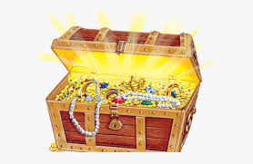

Let’s test the pirate’s treasure to find out if it is magnetic? All the most valuable treasure will stick to a magnet!!

- Use a strong fridge magnet for this experiment.

- Make a collection of small items from around your home that you know are magnetic: screws, paperclips, staples, metal ball bearings, picture hooks, coins, etc.

- Make a collection of non-magnetic items such as buttons, plastic sorting toys, beads, foam shapes, paper stars, chocolate coins, etc.

- Place both magnetic and non-magnetic items on the kitchen table and use fridge magnet to see what sticks to it.
What happens?
Why do some items stick to the magnet?
whilst others don’t?

History

Old forms of transport
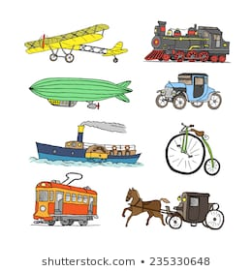
Discuss – Do we use them anymore? Do they travel by ground/air/water? What do we use instead? Which one do you like the best?
S.P.H.E.

(Stay Safe Programme: Topic Lesson 2 – Feeling Safe and Unsafe)
Tom’s Story

It was a really nice day when Tom woke up. The sun was shining in through his bedroom window and he could hear the birds singing outside. He jumped out of bed and ran into his Mum’s room. She was already up and dressed. “Mum, Mum”, said Tom, “it’s a really nice day and you promised we could go for a picnic if it was nice today”. “That’s right”, said Mum, “I did say that, didn’t I? Why don’t you get dressed, then we’ll have breakfast and pack up a picnic, but I will have to stop at the shop on the way to get some fruit juice to drink.” Tom was really quick about getting dressed and eating up his breakfast. He even helped Mum pack up the bag with all the picnic things and very soon they were on their way
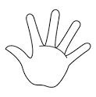

TASK:
Trace out your child’s handprint and write out a person they trust on each finger

Geography

Draw your own treasure map!
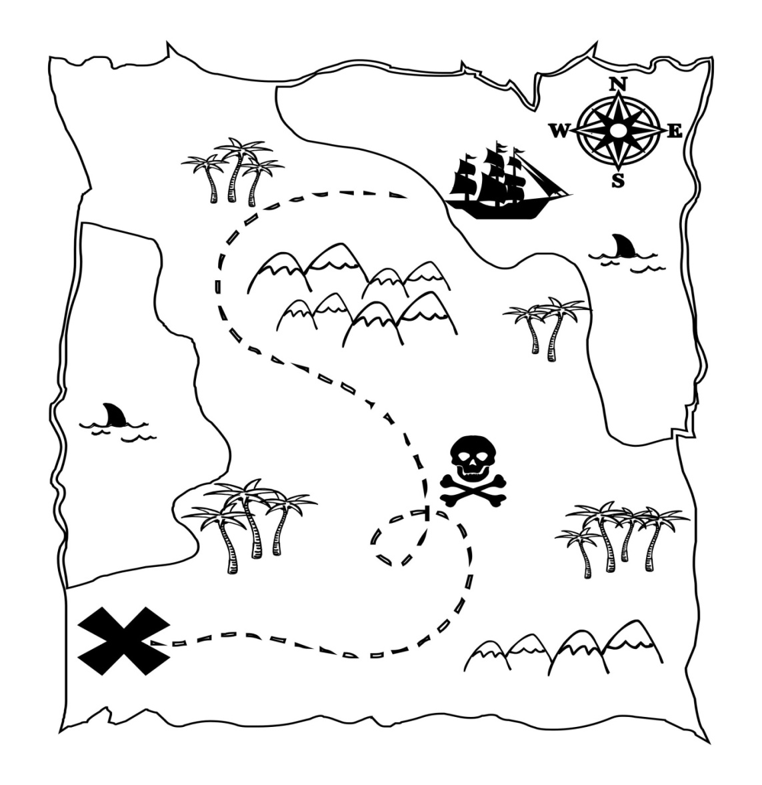
Draw an outline of your island and add 4 symbols e.g. palm trees, volcano, hills, pirate ship, treasure chest or x marks the spot. The choice is yours! Here is an example to help. Keep this map for art on Friday.

Teabag Treasure Map

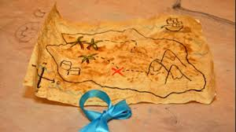

You will need:
- Your map
- 1 teabag
- Hot water

To make:
- Take your map and scrunch it up into a ball.
- Open and flatten out. This will help make the map look really old.
- Put teabag in a cup of hot water and let it sit for a few minutes.
- Starting from the top of the page, dab with the teabag until it is completely covered.
- Don’t worry if it bursts open, use a clean tissue to dab off and keep going with a new teabag.
- Let it dry out and there you go! A lovely realistic looking treasure map! Get treasure hunting!
*Step by step instructions available at https://www.kiwico.com/diy/Arts-and-Crafts-Ideas/1/project/Tea-Stained-Treasure-Maps/752

