4th Class work – Mrs Humphreys & Mrs O’Connor – week of the 27/04/2020

Hi Everyone
Tá súil agam go bhfuil sibh go léir ar mhuin na muice and that nobody is’ tuirse traochta’.
We hope you are finding the work we have set manageable and we would love to hear from you. You could take a photo of anything you have done and email it to us.
Gaeilge:
Last week you had to read Láib on pages 98&99. You can hear someone reading this if you click on this website www.my.cjfallon.ie Go to student resources, click primary, then 4th class, then Gaeilge, then Bun go Barr. You will find the audio for pages 98 & 99. We will put a translation of it at the end of this and you can see how you got on.

This week we would like you to do :
Gaeilge:
Bun go Barr P100. Cupla Ceist .Remember P.137 will help you if you get stuck.( Answers next week)
P 102 H &I J As you know already when you add ‘an domhain’ to a feeling it means ‘very’ so ‘áthas an domhain’ means ‘very happy’
Remember that ‘nuair’ is a connecting word that means ‘when’ when you are doing J.

Maths:
Fractions> Operation Maths
- Look at your Fraction Wall on page 68 and revise questions !,2 ,3 & 4 and Work it out.
- I am learning to calculate a fraction of a set. Look at example on page 69 NOTE( we do it differently to the book and don t use bar models)
Draw 24 apples
Next find 1/6 (one sixth) of them by circling groups of 6. How many groups did you get? Yes you got 4 groups of 6 so
1/6 of 24 = 4
So 5/6 is = to 4+4+4+4+4= 20 or 4x5=20

Did anyone figure out the faster way of doing these?. Normally we let you figure it out for yourselves by doing lots of examples but we will just tell you on this occasion.
Divide by the bottom and multiply by the top. .
Show you answer like this:
Find 5/6 of 24
1/6 = 4
5/6 = 4 x 5 =20
Tip; Always find one fraction of it first.
Try questions 1 on page 69 and 3 on page 70. ( Answers next week unless you want to take photo and email answers before then)
If you are finding these too difficult don’t worry or if you need an extra challenge go to my.cjfallon.ie . Go to student resources click primary click 2nd or 3rd if you want to find easier fractions or 5th and 6th class book if you want a challenge . Click Maths click Busy at Maths
There are tutorials for some pages of the Busy at Maths if you need help.

English/ History/ Geography
Theme: Japan

History:
Small World Princess Hase of Japan . Read pages 58 & 59
Try to read and understand at least ten new words. The more ‘vocabulary rich’ you are the better you will understand what you are reading.
Geography;
Small World , page 78 Read this page and try to understand and remember as much as you can. Write 10 to 20 important words that will help you summarise the page.
Look at the map of the world on pages 74 and 75 and see where Japan is in relation to Ireland. If you are able to print a map of the world from Twinkl colour in Ireland and Japan only. You can use this for your project later. You could also do a rough tracing.. There is a map of Japan on page 63..

Music
Listen to the recording of Edelweiss on the tin whistle. We also include the notes.
Try and learn to play this over the next few weeks.
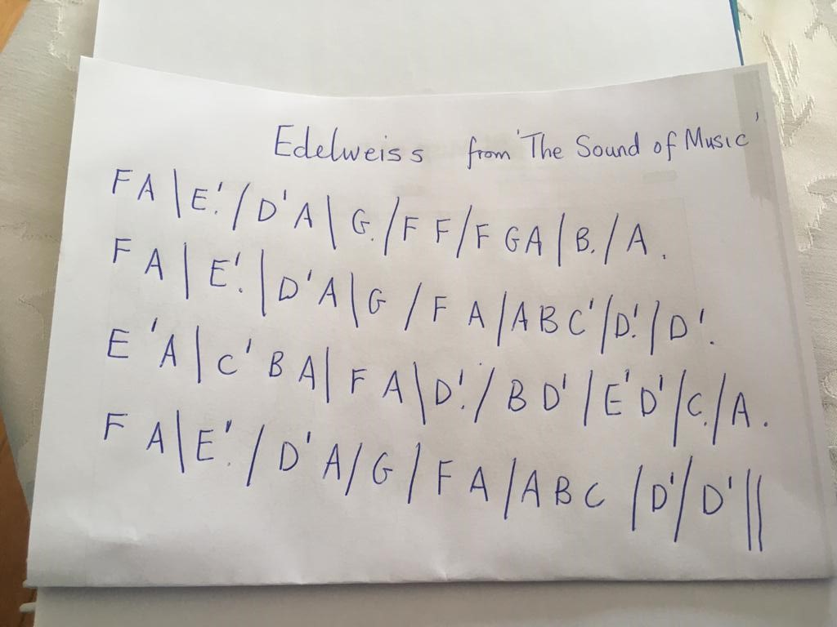

P.E
Dance- Waltz
Look at this YouTube clip of a couple doing a Waltz dance performance of Edelweiss.
https://youtu.be/FX_X1nSgyFo
If someone at home is able to waltz, maybe they might show you how too waltz.

Religion
Grow in Love – read pg 58-63.

Translation for last weeks Láib
- Rossa, Neasa and Tomás were walking to school in the morning. It was a wet day. It was raining.
- The boys started messing. Suddenly, Rossa slipped. He fell in the mud.
- When Rossa stood up, his clothes were dirty. Rossa was very angry.
- When Rossa reached the school, the other children started laughing. Rossa was very embarrassed.
- Síobhán – What is this Rossa? The new fashion is it? Colm – Where did you buy those new clothes Rossa? Eimear – The new clothes are lovely! Brian – I like the new style Rossa. Aoife – Poor Rossa! Don’t be mocking him. Tomás – Take no notice of them Rossa. Come here.
- Tomás and Rossa went into the classroom. The teacher saw the boys.
- Teacher – Oh my God! What happened? Rossa – I was walking to school and I slipped. I fell in the mud. Teacher – Clean your hands and go to the principal.
- Rossa and Tomás went to the office. The principal called Mammy and Daddy. Daddy or Mammy were not at home. The principal called Granny.
- Granny and Gordó came to the school. Rossa went home with them.
- Granny took his clothes. She washed the clothes in the washing machine. She dried the clothes in the drier. Then, she ironed them.
- She gave a cup of cocoa and chocolate cake to Rossa. Rossa was very happy then.

