35

SIMPLE OUTDOOR ACTIVITIES FOR KIDS for

active month

June 2020

Here are 35 simple outdoor activities for kids to get them outside and active for the month of June. Browse through the list of fun things to do outside with your kids and have fun!! Click on blue links for more information.
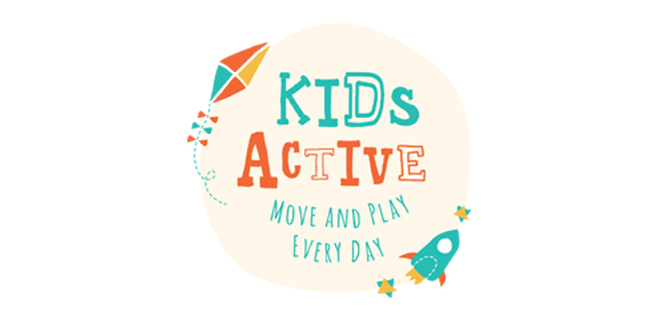
- Go on a bug hunt. – They don’t have to be real bugs if you don’t want them to be.
- Run through a sprinkler.
- Play in a sandbox.
- Investigate your yard with a magnifying glass.
- Paint some rocks with watercolors.
- Wash the paint away with the hose.
- Hunt for “dinosaur bones”
- Play with a hose.
- Play Angry Birds (with water balloons).
- Hose down some chalk letters and shapes.
- Ride a bike or scooter around the block.
- Plant something (anything) in the garden.
- Mix some colors with water balloons.
- Play with a water table or make your own.
- Climb up a tree, a wall or a jungle gym.
- Have a backyard toy car wash.
- Wash a real car.
- Go on a nature scavenger hunt.
- Dig in the dirt.
- Jump in puddles.
- Have a soccer shoot out all you need is a ball big enough to kick.
- Paint with a fly swatter.
- Take a dog for a walk.
- Put down some painter’s plastic, grab a hose and have a homemade slip and slide!
- Make a stepping stone for your garden.
- Color the patio with sidewalk chalk.
- Play catch with a ball (or water balloons on a hot day).
- Paint like Jackson Pollock.
- Spray paint.
- Graffiti the driveway.
- Stack and balance rocks.
- Go on a sound safari.
- Make a treasure map and find treasure.
- Host the mini Olympics.
- Have a waterfight!!

