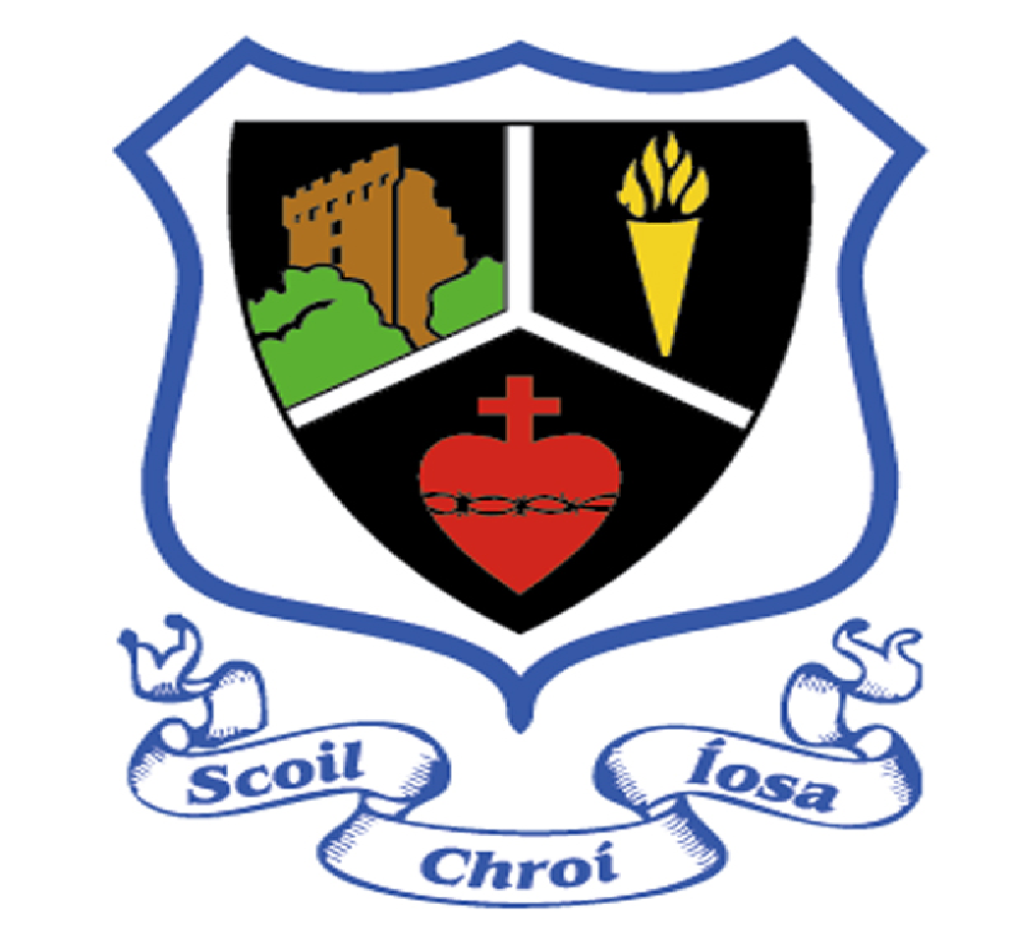

Scoil Chroí Íosa
ANNUAL ADMISSION NOTICE
in respect of admissions to the 2023/24 school year
Admission Policy and Application Form
A copy of the school’s Admission Policy and the Application Form for Admission for the school is available as follows: –
To download at: www.scins.ie
On request: By emailing principal@scins.ie or by writing to The Principal, Scoil Chroí Íosa, St. Anne’s Road, Blarney, Co. Cork.

PART 1 - Admissions to the 2023/24 school year

Application and Decision Dates for admission to Scoil Chroí Íosa
The following are the dates applicable for admission to Junior Infants

The school will commence accepting applications for admission on | Monday 3rd October 2022
The school shall cease accepting applications for admission on November 7th of the year preceding the start of the school year for which admission is being sought | Monday 7th November 2022
The date by which applicants will be notified of the decision on the application | Monday 28th November 2022
The period within which applicants must confirm acceptance of an offer of admission is | Monday 12th December 2022
*Failure to accept an offer within the prescribed period above may result in the offer being withdrawn

Note: the school will consider and issue decisions on late applications in accordance with the school’s admission policy.

Special Class Application and Decision Dates for admission to the school year 2023/24
The following are the dates applicable for admission to the school’s Special Class which caters for children with Developmental Language Disorder
The school will commence accepting applications for admission to the special class on | January 5th 2023
The school shall cease accepting applications for admission to the special class on | February 11th 2023
The date by which applicants will be notified of the decision on their application for admission to the special class is currently under review. | Date TBC
The period within which applicants must confirm acceptance of an offer of admission is currently under review. | Date TBC
*Failure to accept an offer within the prescribed period above may result in the offer being withdrawn

Number of places being made available in Scoil Chroí Íosa

The number of places being made available in Junior Infants is | 44
The number of places being made available in the special class catering for children with Developmental Language Disorder is | 7*
*This number is dependent on the number of children being retained in the class for a second year

PART 2 - Admissions to the 2022/23 school year
Information regarding the admission process for the Intake Group for Junior Infants for the school year

In respect of the 2022/23 school year
In respect of the 2022/23 school year, the total number of applications for admission received by the school was:
Breakdown of places allocated for the 2022/23 school year:
Number of places available: | 56
Number of applications received: | 40
Number of Offers made and accepted under each criteria: | Criterion were not applied as Junior Infants was not oversubscribed
Total number of offers made | 40
Number of names placed on waiting list for the school year concerned. | 0

Information regarding the admission process for the Intake Group for the Developmental Language Disorder class for the school year 2022/23
Breakdown of places allocated for the 2022/23 school year:
Number of places available: | 7
Number of applications received: | 6
Total number of offers made | 3
Number of names placed on waiting list for the school year concerned. | 0

