French Armada in Bantry Bay

In 1794 Wolfe Tone and his United Irishmen friends began to seek armed aid from Revolutionary France to help overthrow English rule. In February 1796 Tone arrived in the French capital with a plan for a French invasion of Ireland and was favourably received. He claimed that the Irish people would rise in rebellion if supported by France. One of the most brilliant young French generals, Lazare Hoche, was appointed to command the expedition. Tone was made an adjutant in the French army.
On December 16, 1796, Tone sailed from Brest, France, with 42 ships and some 14,000 men, but they did not predict the bad weather and how difficult the journey would be. The ships were badly handled and were scattered by a storm. The French sailors were not dressed or prepared for such weather and really struggled to work in the conditions.
Though some ships reached Bantry Bay in southwestern County Cork, a number of ships were wrecked and some including the flagship Fraternité (32 guns), carrying the two commanders-in-chief, Morand and Hocheo were blown off course and had to return to France. The ships stayed in Bantry Bay for four days in an attempt to get ashore and march to Cork with the rest of their troops. Bad communication with troops on land meant that their troops on land didn’t even know they were there and didn’t support them. Without the Fraternité the fleet did not have enough arms,food or provisions to keep going . On December 25th 1796, although they were so close to land the storms forced the ships to retreat, “We were close enough to toss a ships biscuit ashore”, wrote Tone in his diary of the failed mission.
Tone would try again two years later but this time the French military leader, Napoleon Bonaparte, took little interest. When the Irish Rebellion broke out in May 1798, Tone could obtain only enough French forces to make small raids on different parts of the Irish coast. In September he entered Lough Swilly, Donegal, with 3,000 men and was captured there.
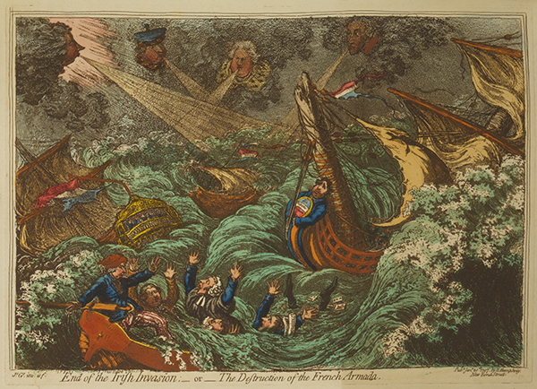
Above: The End of the Irish Invasion; — or — the Destruction of the French Armada (1797) by James Gallray.

Below: A longboat from the frigate Résolue, blown ashore when she came to the assistance of another ship, still sporting her French colours after 220 years, now on display in the National Museum, Collins Barracks.
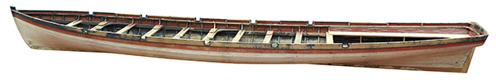

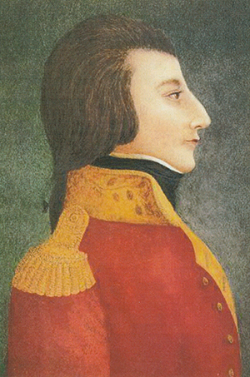 Theobald Wolfe Tone
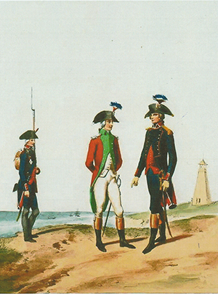 Above: Uniforms of the Armée d’Irlande—an Irish officer (centre), with a French marine private (left) and officer (right).
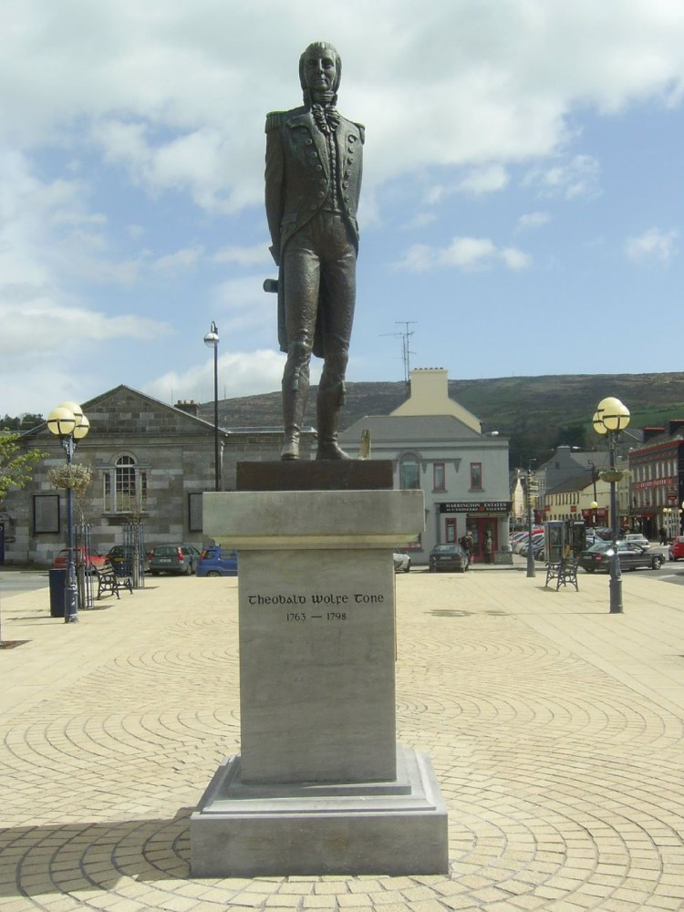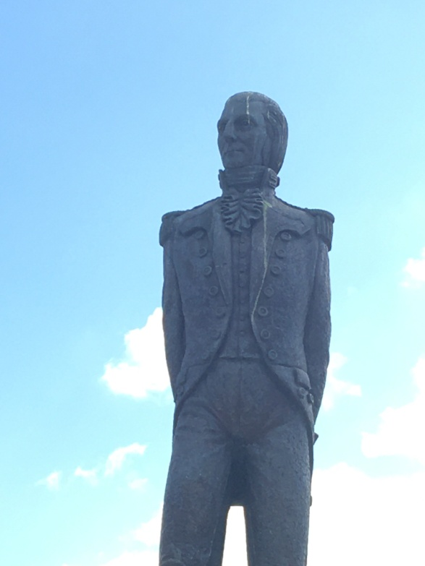
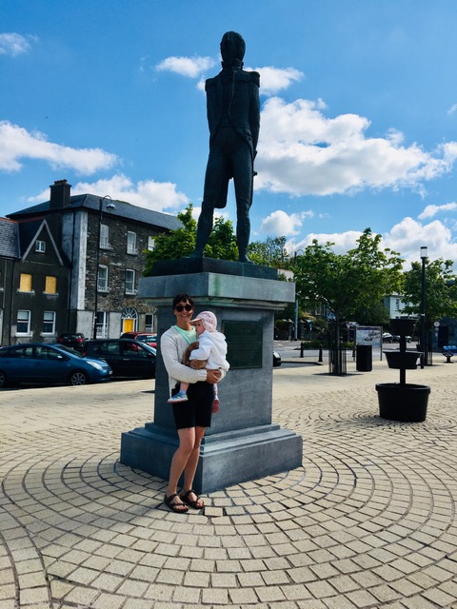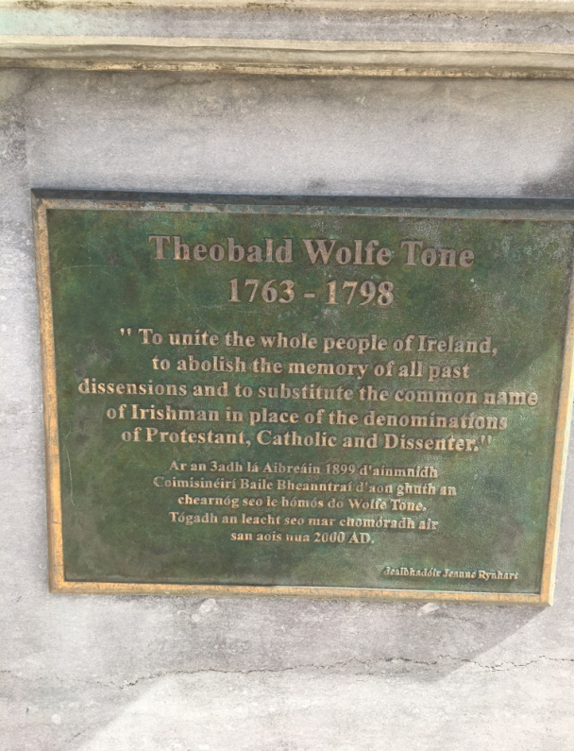

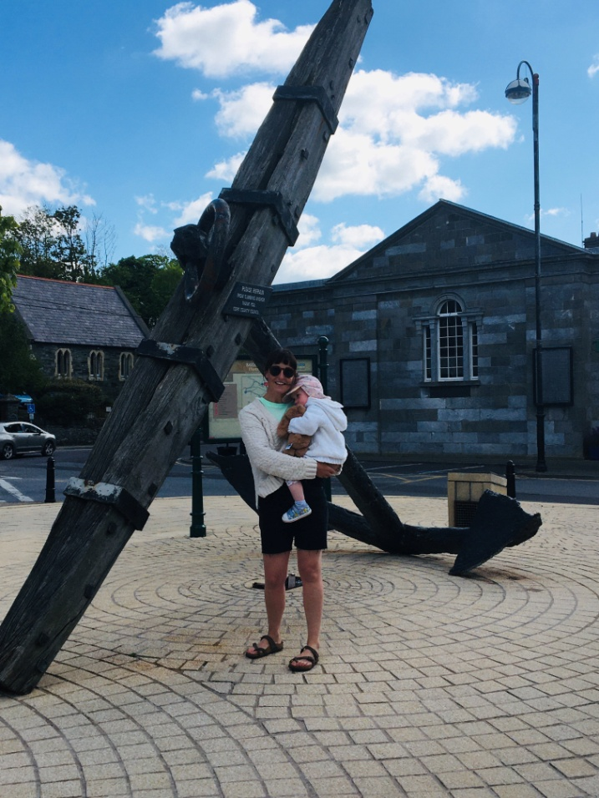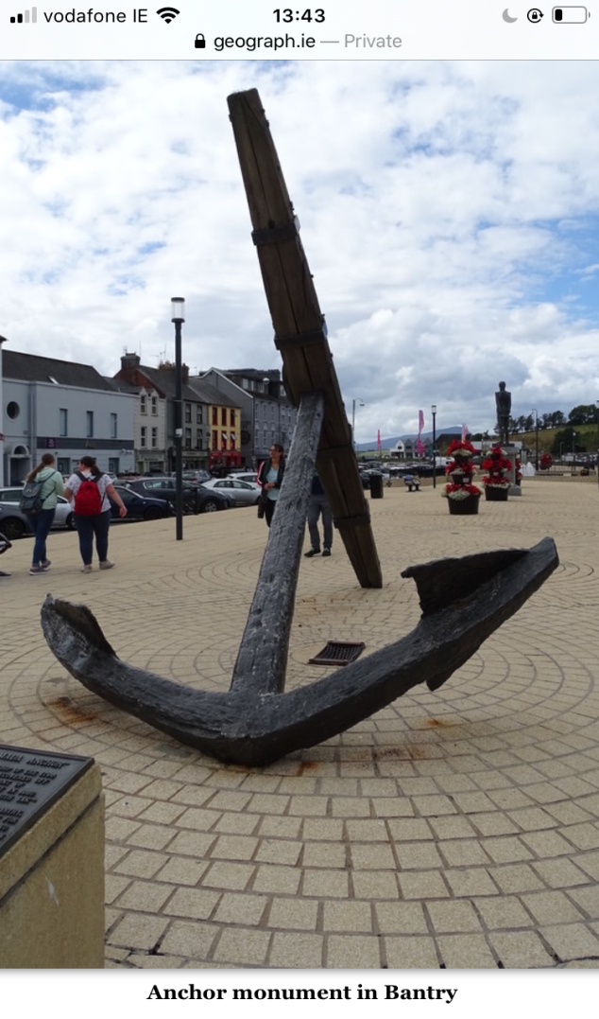

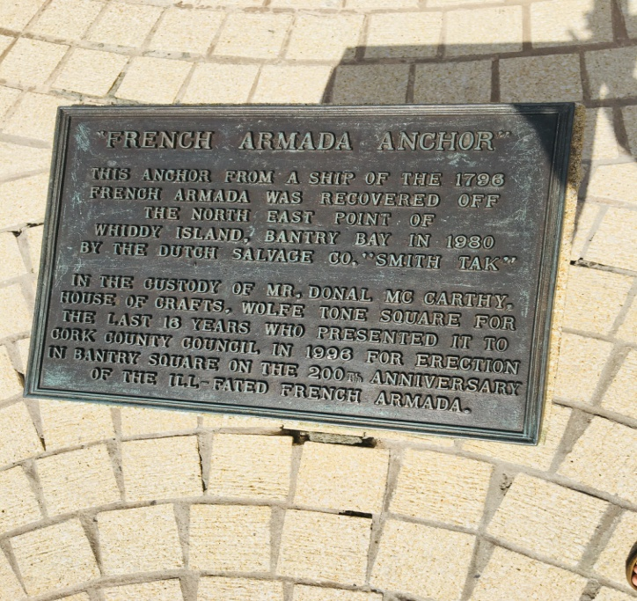

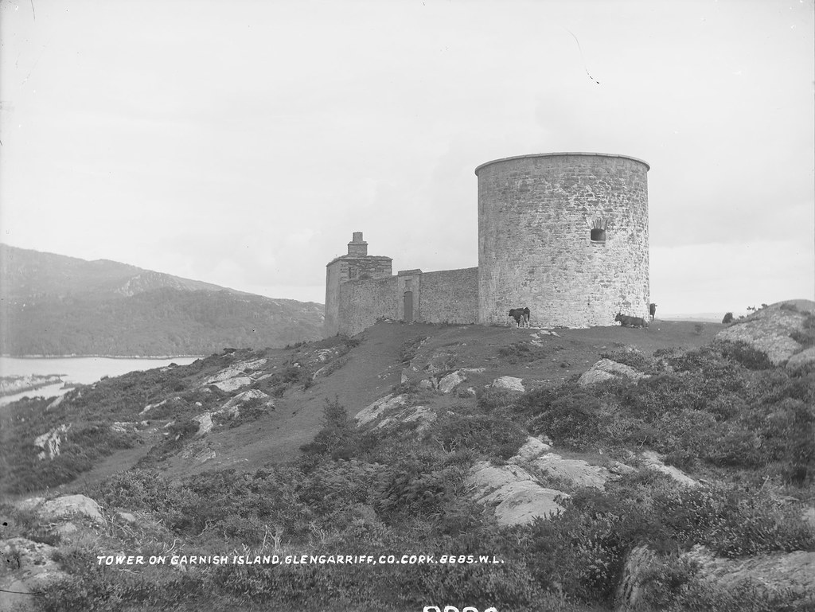
Martello tower in Bantry Bay

Reference:
https://www.historyireland.com/volume-24/close-enough-toss-ships-biscuit-ashore-french-fleet-bantry-bay-1796/

