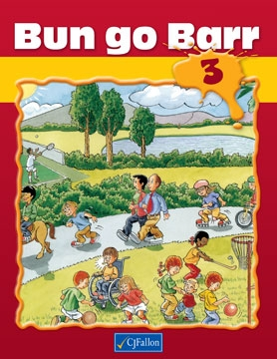

Gaeilge
15th – 19th June – Ag Súgradh sa Pháirc
Ms. McPolin

Translations for Story
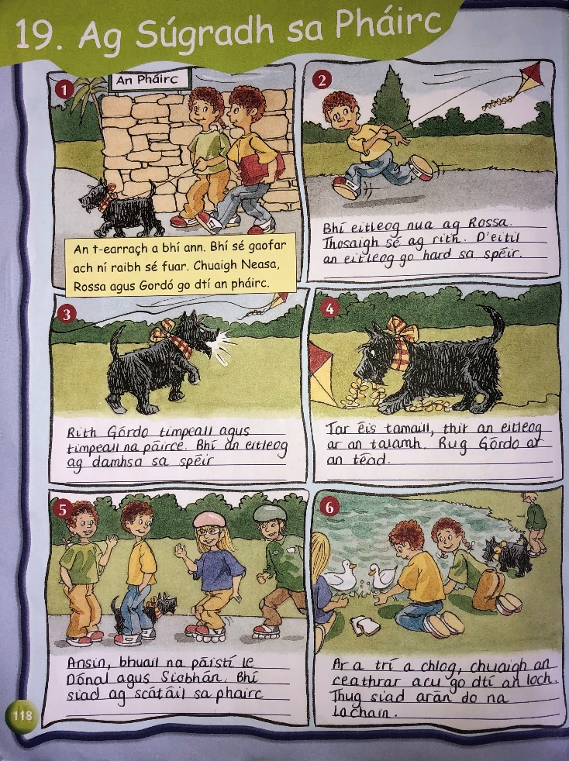

Fóclóir
- An t-earrach – spring
- Gaofar – windy
- Eitleog – kite
- Go hard sa spéir – high in the sky
- Ag damhsa – dancing
- Téad – lead/string
- Sg scátáil – skating
- An loch – pond/lake
- Na lachain – ducks

QC: Scríobh an scéal – writ the story (fill in the blanks)

QD: answer questions (translations below)
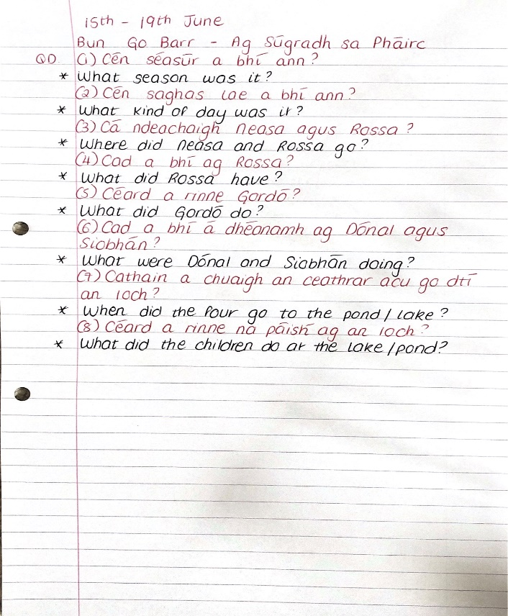

QE: Athscríobh na habairtí – re-write the sentences
QF: Rug Gordó ar an téad – Gordó pulled on the string
- An madra – the dog
- An eitleog – the kite
- An t-úll – the apple
- An mála scoile – the school bag
- An liathróid – the ball
- An rothar – the bike
Look at the pictures and fill in the correct word into the space. Write full sentences in your copy.

