***j0235379Palindromes:***

The words kayak, madam and rececar are palindromes-they read the same written backward. The number 2002 is also a palindrome. Investigate which other years in this century are palindromes. What year will be the next palindromic year?

***Multiple days:***

Using a copy of the December 2005 calendar, and colour every third number with your favourite colour. Does a pattern form?

Try another number and another colour, such as six and red? Why have you coloured several numbers with two colours.

***A 4 Day Week:***

A week has not always been 7 days long! In ancient times a week might be from 4 to 10 days long, depending on the time needed to get ready for the next market day. Calculate the number of weeks that would make a year if a week was 4, 5 or 10 days long. How do your answers compare with the number of 7 day weeks in a year?

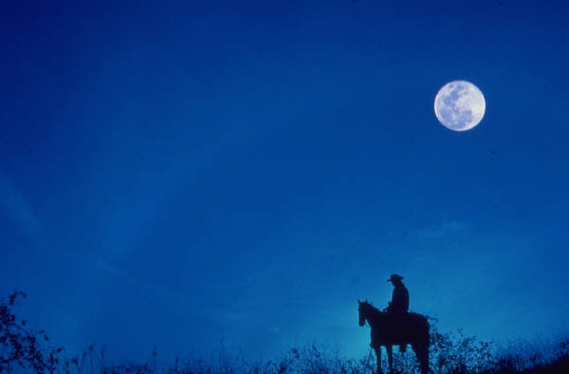***Once in a blue moon:***

The term blue moon describes the second full moon in a calendar month. A full moon happens about every 29.5days. Blue moons are rare and usually occur about every 2.5 years. The first full moon of the new millennium occurred in January 6th, 2001. Predict the month and year when we will have another blue moon.

Use https://nssdc.gsfc.nasa.gov/planetary/lunar/blue_moon.html website to check information, research.