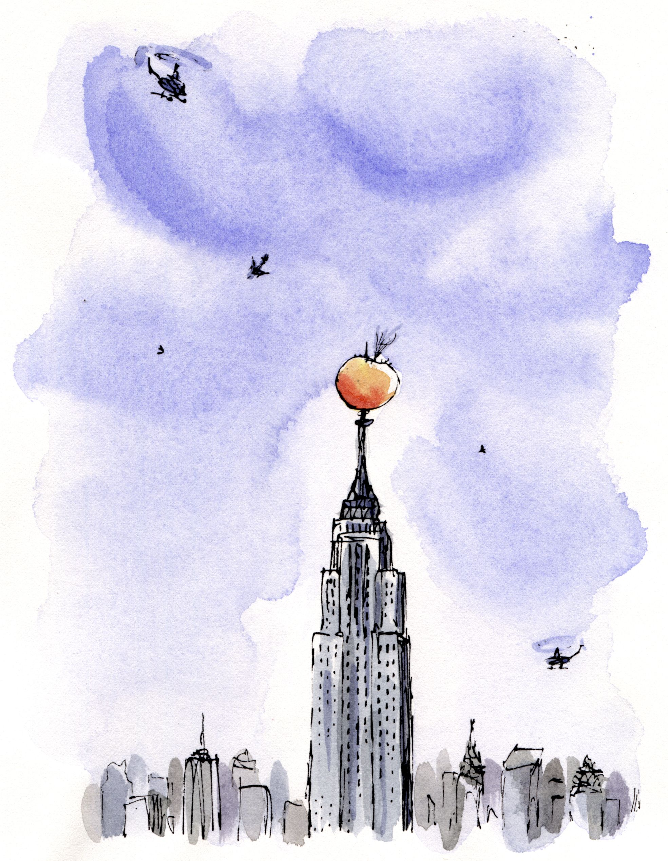

James and the Giant Peach
By Roald Dahl
Third class comprehension work – Ms. McPolin
22nd – 26th June
Chapter 35 | - What could be a good title for this chapter?  - What is a word that means the SAME as plummet?
Chapter 36 | - Why do you think James and the insects were saying goodbye to each other?  - What building did the peach land on top of?
Chapter 37 | - Imagine you are living in New York city when the peach arrives. What do you think it is at first when you see it?  - Name some of the things people thought the peach was.  - What did you think of James’ speech? Did he describe the creatures well?
Chapter 38 | - Pretend you’re the little girl in the red dress. Describe how the peach tasted!  - Draw a picture of the scene on Fifth Avenue as the spectators ate the peach right down to the stone!
Chapter 39 | - With all the things that happened to James, what do you think was the best and what do you think was the worst?  - Can you think of a fairy tale that is similar to James and the Giant Peach? In what ways?  - Choose one character and write a short story about their new life.

