ZOG
By
Julia Donaldson
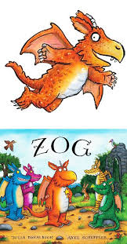
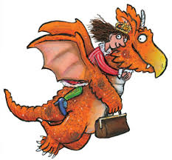

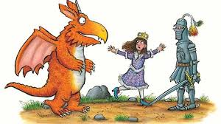

Gordon’s Great Escape
By
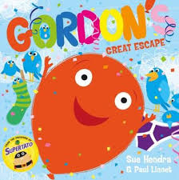
Sue Hendra

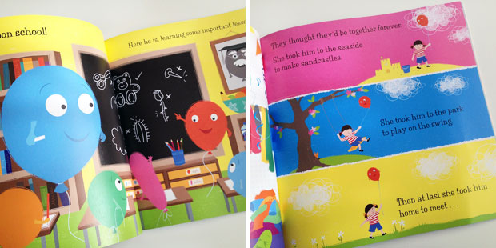

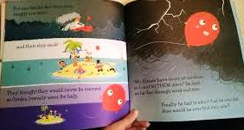

Maths Scavenger Hunts

Monday: Find 3 of each 2D (circle, square, rectangle & triangle) shape in your home/ toy box. Lay out as in picture

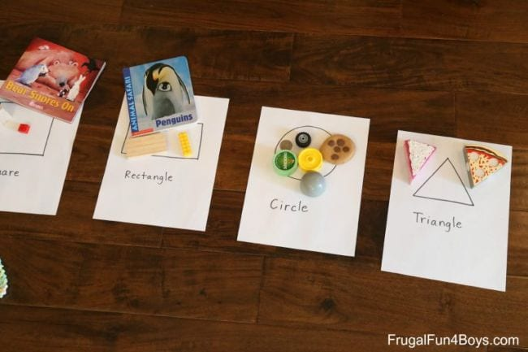

Tuesday: Find 3 of each 3D (sphere, cube, cuboid, cylinder) shape in your home/ toy box

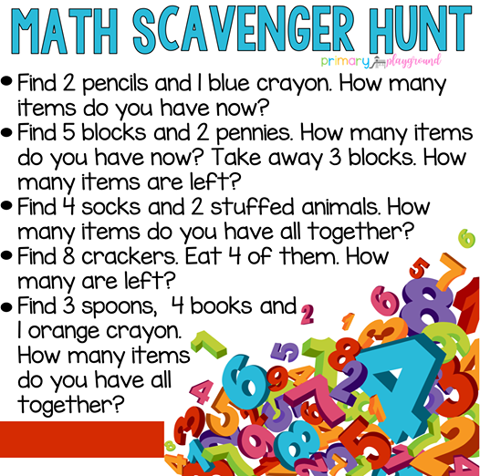
Wednesday:

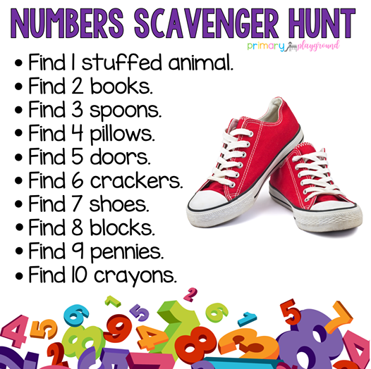
Thursday:

