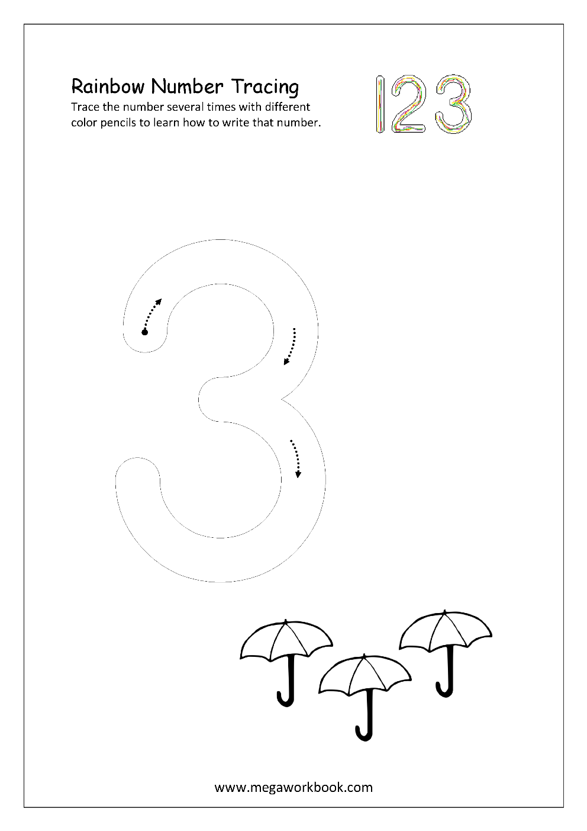

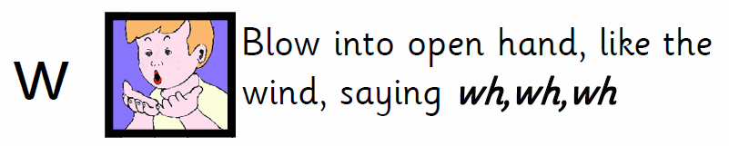
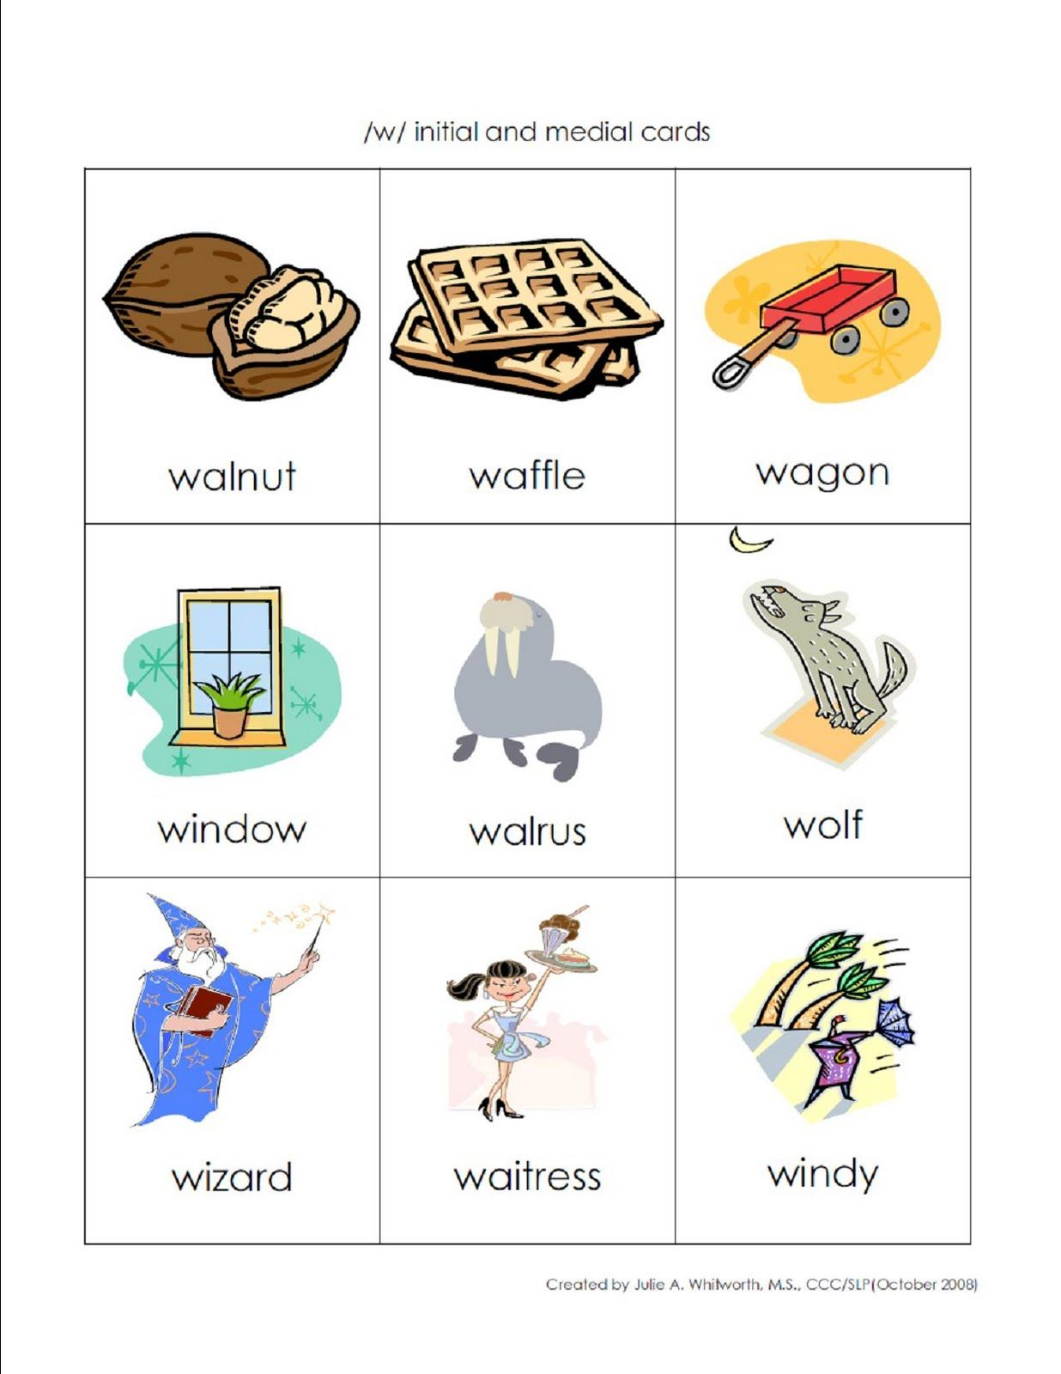
Monday
Tuesday
Practice correct letter formation. Remember to encourage correct grip.

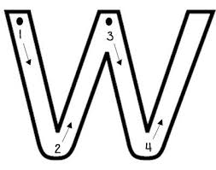

*Practice with finger first.
Start at the top.
Slide down and up the hill.
Slide down and up the hill.

Practice in the air, on tables, on windows, etc.

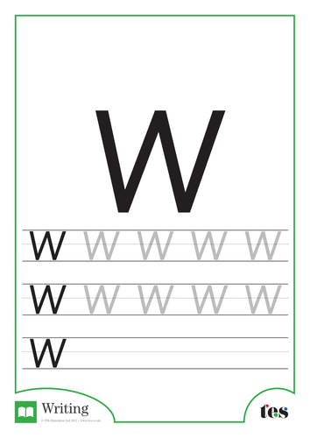
Wednesday – Practice making letter with crayons, pencils, markers, etc
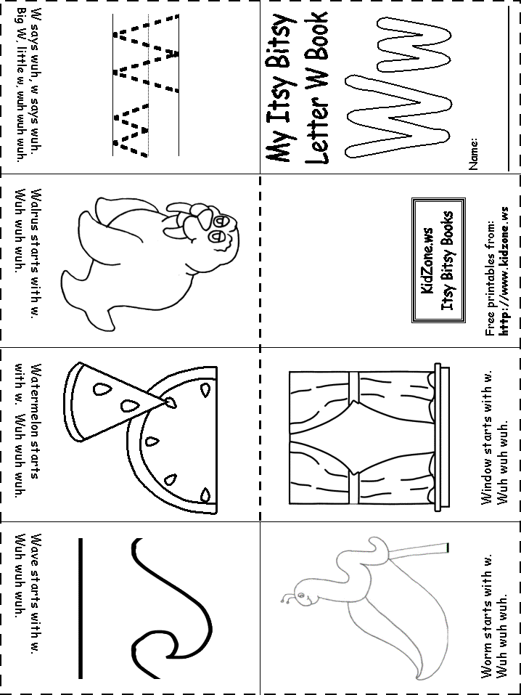
Thursday – Colour in, cut out, staple(adult!) and read

Tricky Words
There are many keywords that are irregular e.g. the, you, etc. These cannot be sounded out. These are called ‘tricky words’ and have to be learned. We say that these words are trying to ‘trick’ us because they do not follow the regular rules. Your child will learn 3 ‘tricky words’ each week in Children should look at the regular parts to help them and identify the ‘tricky’ part. The aim would be that they can recognise these words and be able to read them.
Write them out on small pieces of paper to practice. They will find it difficult at first so do not worry if they tire easily. Leave it and return to another time.
Keep in mind, I will be doing them in new school year.

Week 2 – 20th – 24th April

I
the
he
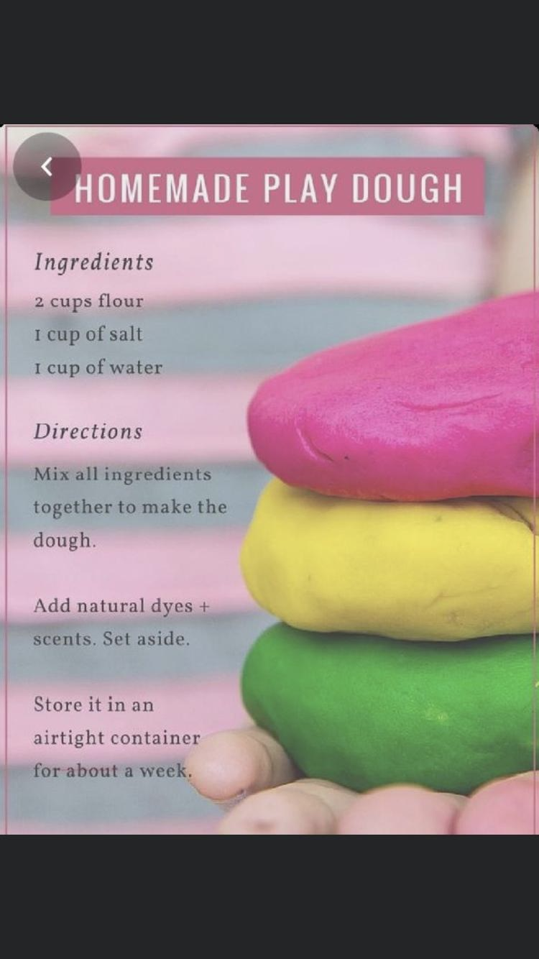
Playdough encourages the development of fine motor skills, concentration, creativity,is relaxing and offers opportunities for the development of language and social skills. Children can help make the playdough.
Playing with playdough helps children:
- Develop sensory experiences
- Express themselves
- Develop their senses
- Enjoy creative activities
- Enhances fine motor skill
- Calming effect
- Develop hand-eye coordination.

Getting Started
Make the dough.
Explore the properties of dough
Squish it, stretch it, roll it.
Patterns – create patterns using hands or textured objects and tools like lego, stickle bricks, pine cones and shape cutter.
Roll it – roll out playdough with a rolling pin– roll a sausage, a ball, a pancake.
Cut it – use a variety of cutters to make shapes.
Colour – add colour using food colour- If colour is added after the dough is mixed there will be a marbled effect.
– A small quantity of colour produces a pastel effect.
Smell add smells using perfumed oils (lavender oil), nutmeg, cinnamon and herbs.
Texture by adding glitter, sand or rice.

Enjoy and have fun…..

