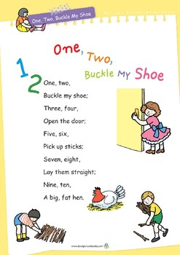
Measures: Money
Language: coin, 1 / 2 / 5 cent, euro, price, cost, buy, sell, spend, spent, pay
Monday – Make coin rubbings – 1, 2 and 5 cent coins to be used. Place coin s under a sheet of paper and rub over with a pencil to see the imprint of the coin. A fun way to introduce coins. Talk about colour, size, weight, pictures, etc.

Tuesday – Play online coin games – activity 13 and 13A http://data.cjfallon.ie/resources/19596/activity-113/index.html
14 / 14A - http://data.cjfallon.ie/resources/19596/activity-114/index2.html
Play these games using real coins

Wednesday – Play online coin games – 15 / 15A http://data.cjfallon.ie/resources/19596/activity-115/index2.html
16 / 16A - http://data.cjfallon.ie/resources/19596/activity-116/index2.html
Play these games using real coins

Thursday – Play online coin games – activity 17 / 17A http://data.cjfallon.ie/resources/19596/activity-117/index2.html
18 / 18A - http://data.cjfallon.ie/resources/19596/activity-118/index2.html
Play these games using real coins

Friday – Play online coin games – activity 19 / 19A
http://data.cjfallon.ie/resources/19596/activity-119/index2.html
20 / 20A - http://data.cjfallon.ie/resources/19596/activity-120/index2.html
Play these games using real coins
Monday
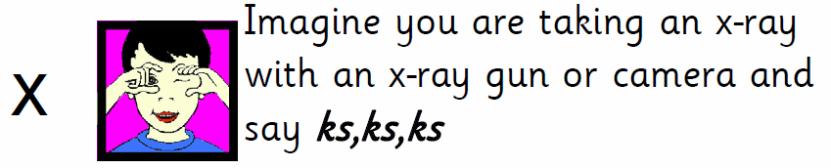

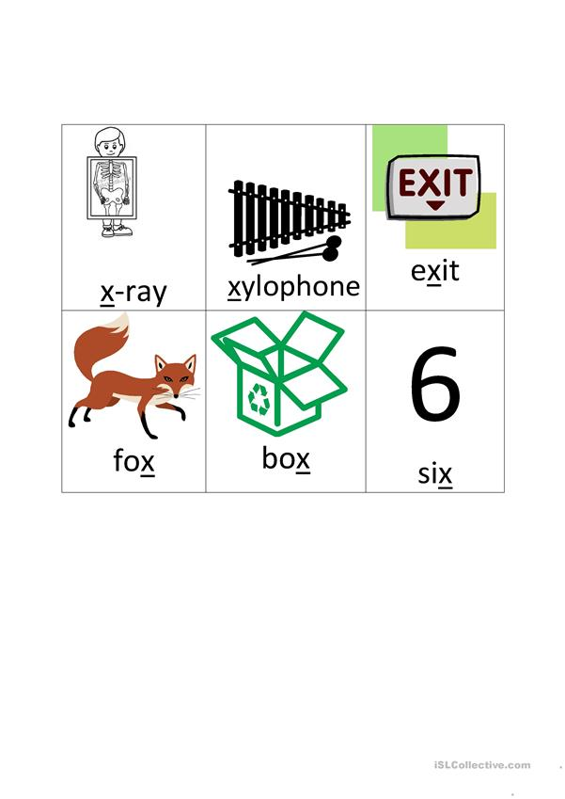
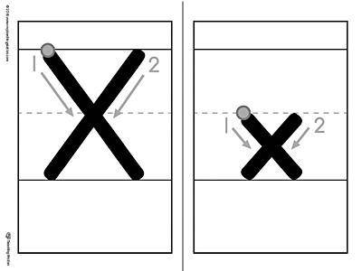
Tuesday
Practice correct letter formation. Remember to encourage correct grip.

Practice in the air, on tables, on windows, etc using peter pointer finger.

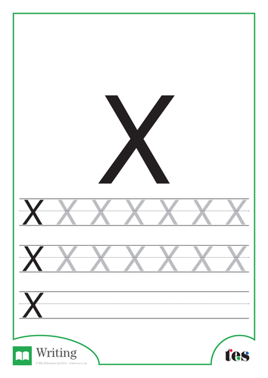
Wednesday
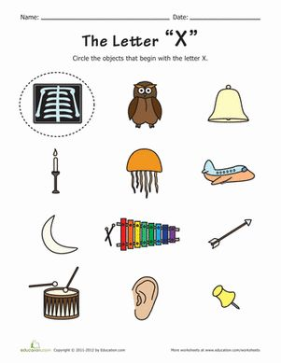
Thursday
Tricky Words Week 5

do
are
all

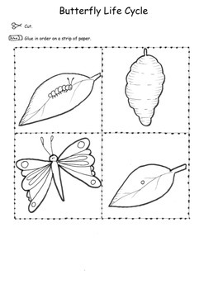
Science
Option 1– print off, colour, cut out and put in order on a strip of paper and discuss. Egg-caterpillar-cocoon-butterfly
Option 2- Draw and colour in pictures in order as above.

History
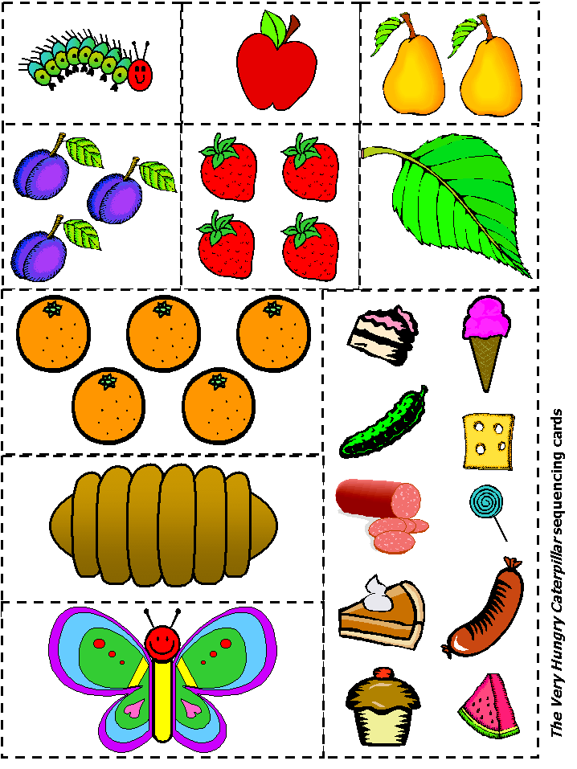
Using book or online version of story, discuss the order the story happens in. Use these pictures to help. Language - First, second,
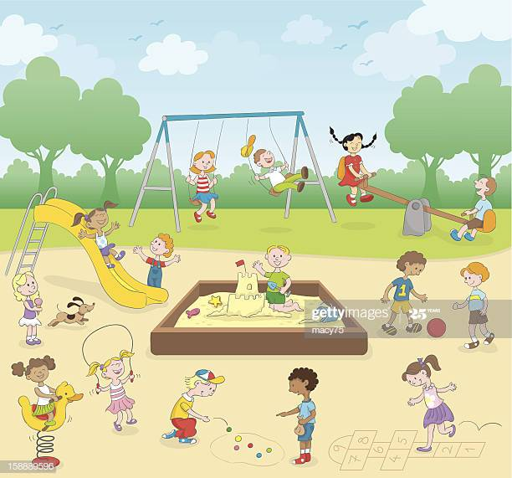
Geography
Discuss picture and a local playground you may visit.
Create your own play ground.
Ideas – water slides, zip lines, forts, pirate ship. Have at least 4 objects in your design. Let your imagination run wild!
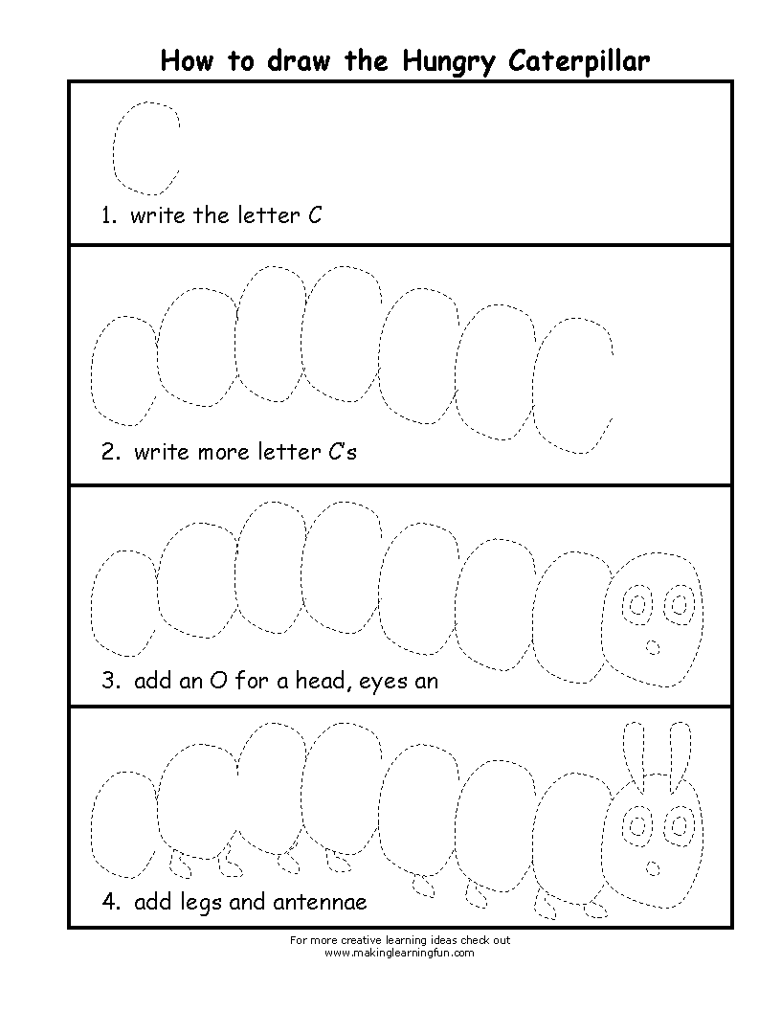
Art

