Limestone and Vinegar: How to Test a Rock
You'll need a few bowls (one for each rock) and some vinegar (regular strength White Vinegar Distilled that you would use for cooking or cleaning) for this experiment.
Glass or plastic bowls.
I would not use metal as sometimes metal and acids will have their own reaction and can change the results of your experiment.
Place one rock in each bowl and pour vinegar over it -- try to cover at least half of the rock.
Vinegar has a very strong small so this is why we should do this experiment outside.
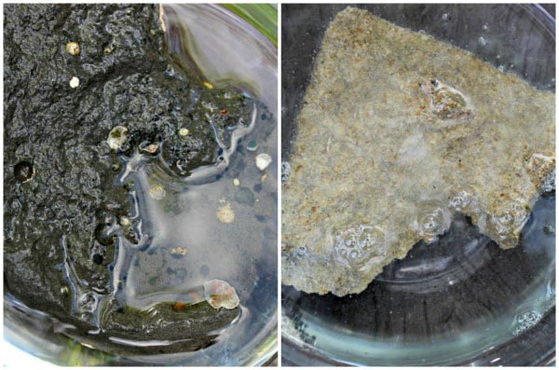
Within a minute, you should see bubbles forming around your limestone rock!

The Science behind the Experiment
Vinegar is an acid and as it interacts with the calcium carbonate in the limestone, it releases carbon dioxide -- and when carbon dioxide is released in a liquid, it forms bubbles.
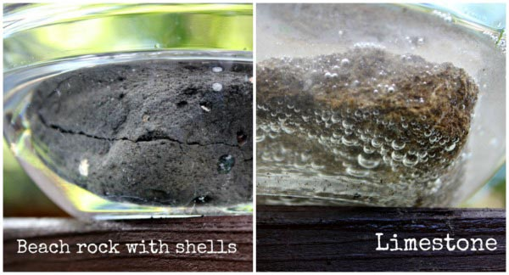
So here's why I use the Glass Bowls or Mason Jars for many of our science experiments -- you can see things from all angles!
After 5 minutes, we can look from the side of the bowl and clearly see the bubbles forming around the limestone rock but not the rock we found at the beach.
Now I really thought we'd see a few bubbles with this rock since it contains some shells but they must not be the type of shells that are made with calcium carbonate. This test can tell you quite a bit about various rocks and minerals.

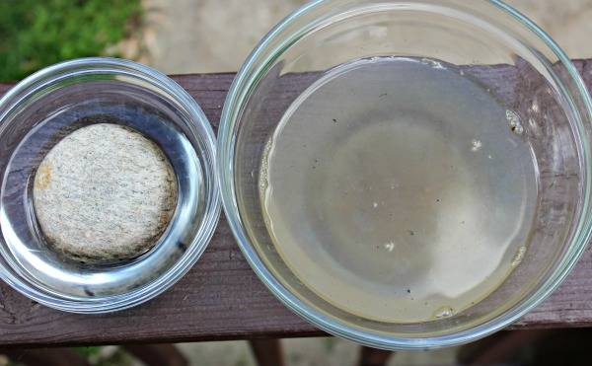
Here's a picture of the river rock (on the left) -- no bubbles what-so-ever after 10 minutes so we know that rock is NOT limestone for sure.
The bowl on the right contained our limestone rock and once you remove the limestone rock, you can see there is a lot of stuff in the bowl!
It looks like sand, dirt and other small particles -- which is exactly what it is!

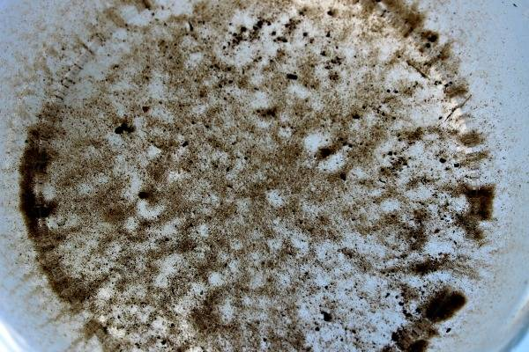
And this is what it looks like through the bottom of the bowl.
The chemical reaction with the limestone (calcium carbonate) and vinegar begins to break down the rock into the minute particles of sand, dirt and shells that are part of its' composition.
Try it yourself at home.

