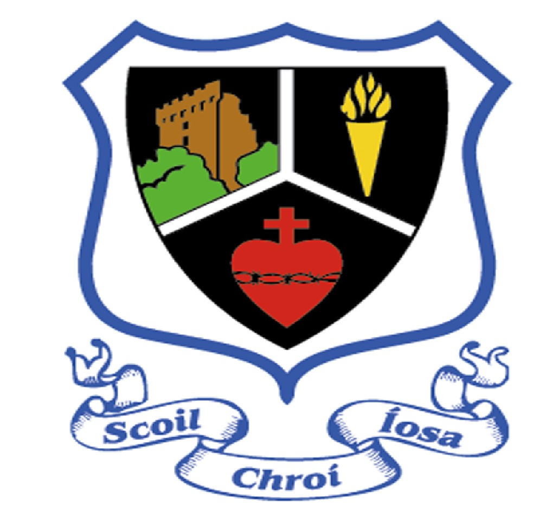
Scoil Chroí Íosa
ANNUAL ADMISSION NOTICE
in respect of admissions to the 2024/25 school year

Admission Policy and Application Form
A copy of the school’s Admission Policy and the Application Form for Admission for the school is available as follows: –
To download at: www.scins.ie
On request: By emailing principal@scins.ie or by writing to The Principal, Scoil Chroí Íosa, St. Anne’s Road, Blarney, Co. Cork.
PART 1 - Admissions to the 2024/25 school year

Application and Decision Dates for admission to Scoil Chroí Íosa
The following are the dates applicable for admission to Junior Infants
The school will commence accepting applications f | or admission on | Monday 2nd  October 2023
The school shall cease accepting applications November 6th of the year preceding the start of which admission is being sought | for admission on the school year for | Monday 6th  November  2023
The date by which applicants will be notified of application | the decision on the | Monday 27th  November  2023
The period within which applicants must confirm acceptance of an offer of admission is |  | Monday 11th  December  2023
*Failure to accept an offer within the prescribed period above may result in the offer being withdrawn
Note: the school will consider and issue decisions on late applications in accordance with the school’s admission policy.

Special Class Application and Decision Dates for admission to the school year 2024/25
The following are the dates applicable for admission to the school’s Special Class which caters for children with Developmental Language Disorder
The school will commence accepting applications for admission to the special class on | January  2024 | 8th
The school shall cease accepting applications for admission to the special class on | February  2024 | 21st
The date by which applicants will be notified of the decision on their application for admission to the special class is currently under review. | March  2024 | 20th
The period within which applicants must confirm acceptance of an offer of admission is currently under review. | April  2024 | 10th
*Failure to accept an offer within the prescribed period above may result in the offer being withdrawn

Number of places being made available in Scoil Chroí Íosa
The number of places being made available in Junior Infants is | 35
The number of places being made available in the special class catering for children with Developmental Language Disorder is | 7*
*This number is dependent on the number of children being retained in the class for a second year

PART 2 - Admissions to the 2023/24 school year
In respect of the 2023/24 school year
In respect of the 2022/23 school year, the total number of applications for admission received by the school was:
Breakdown of places allocated for the 2023/24 school year:
Number of places available: | 44
Number of applications received: | 50
Number of Offers made and accepted under each criteria: | Criterion were not applied as Junior Infants was not oversubscribed
Total number of offers made | 40
Number of names placed on waiting list for the school year concerned. | 6
Information regarding the admission process for the Intake Group for the
Developmental Language Disorder class for the school year 2022/23
Breakdown of places allocated for the 2022/23 school year:
Number of places available: | 3
Number of applications received: | 8 applicants (3 for Blarney & 5 for Glounthaune) applied to both schools
Total number of offers made | From Scoil Chroí Íosa, 3 offers of places were made and 3 offers were accepted.  Scores on Prioritisation Rating Scale for successful applications were used exclusively for the granting of places.
Number of names placed on waiting list for the school year concerned. | 2 children on joint waiting list of Scoil Chroí Íosa and Glounthaune NS

