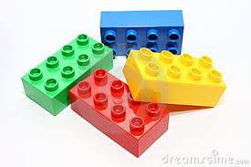
Lego Subtraction

Build 2. Take away 1 How many now? Write out the sum. 2 – 1 = 1

Examples:
1-1= 2-1= 3-1= etc.

Language to use: Two take away one equals one.

Do 5 sums each day.
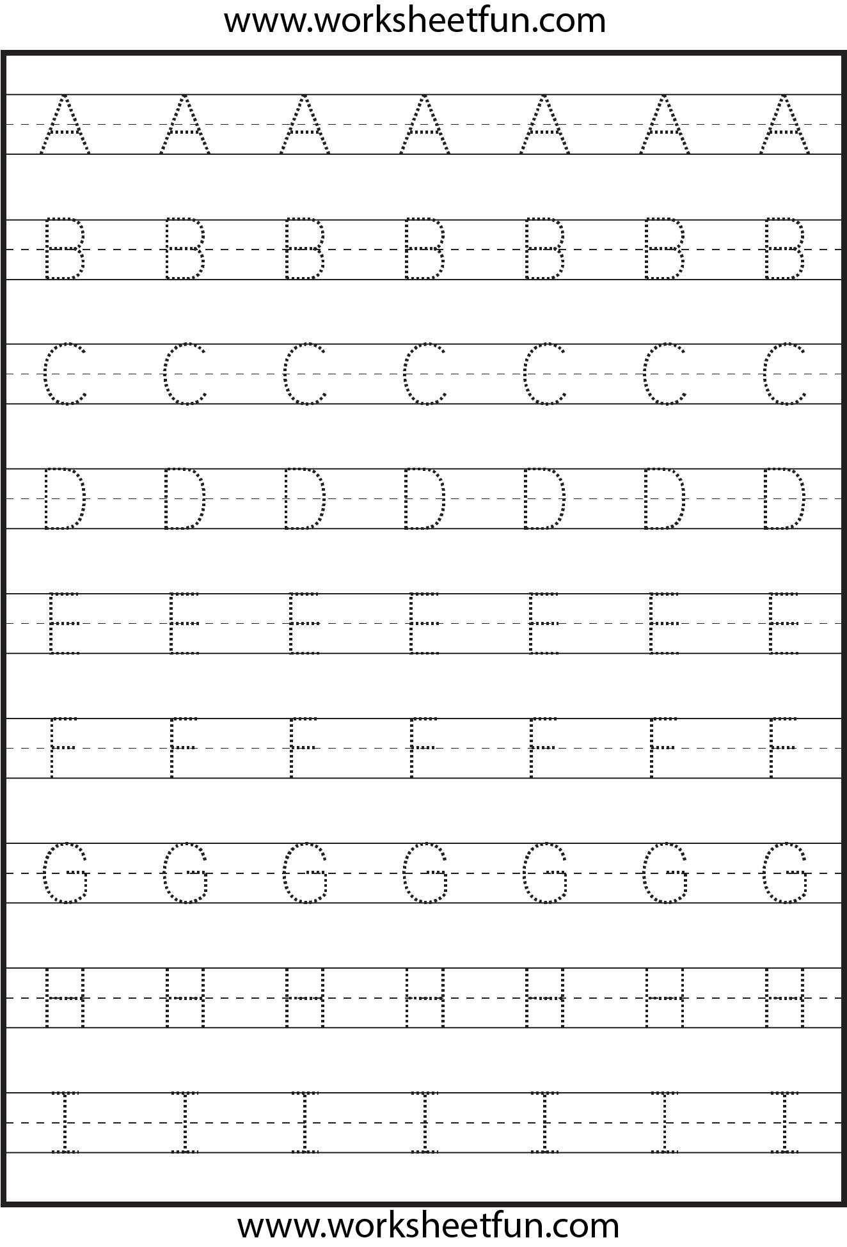
Ooey Gooey

Oooey Gooey was a worm
And a mighty worm was he
He sat upon a railroad trac k
And a train he did not see,
Oooey Gooey!

Draw a picture of the train and Ooey Gooey
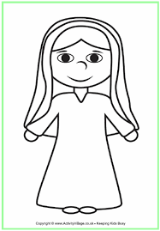
May is the Month of Mary.

Mary had a son called Jesus. Yes / No
Mary was married to Fred. Yes / No
We celebrate Mary at Easter. Yes / No
Mary was sad when Jesus died. Yes / No
My Family Tree - Draw pictures of your family members on leaves. Include your sisters, brother, parents, grandparents and yourself . Use family tree and leaves template here or make your own.

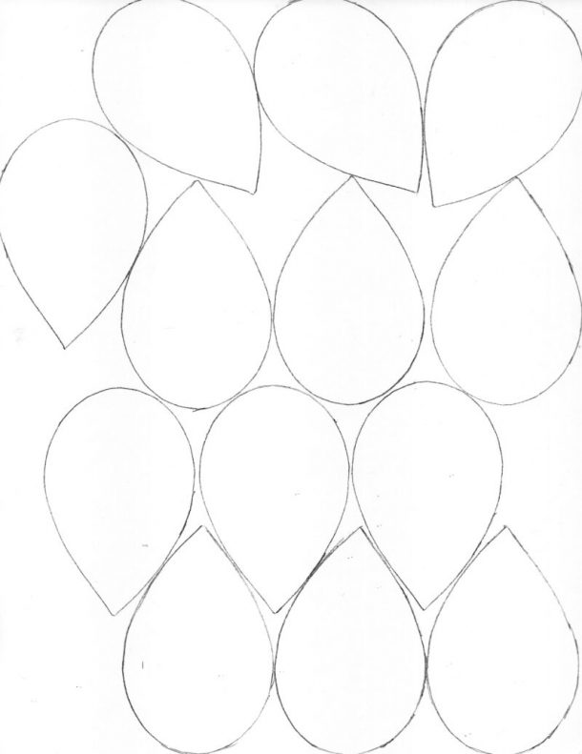

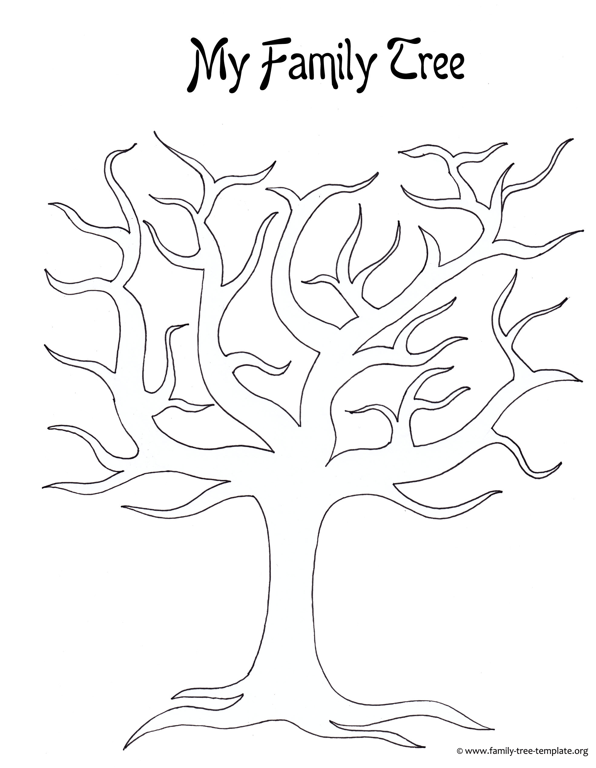
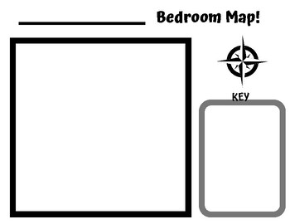
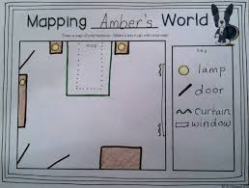
Draw the bed, wardrobe and one more piece of furniture on your map. Here is an example.

