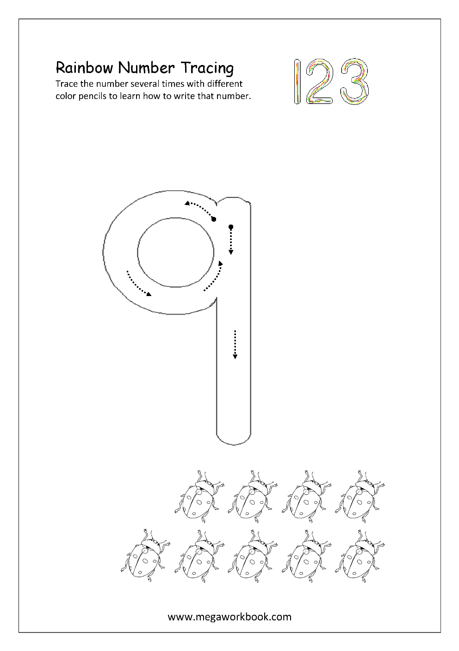
Tricky Word Spelling List – Wk. 2
Cover, say and write:
11. are
12. all
13. you
14. your
15. come
16. some
17. said
18. here
19. there
20. they

*Remember to write on the line!
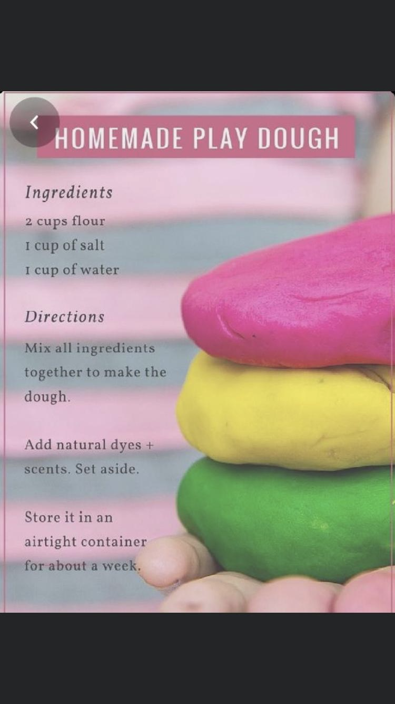
Playdough encourages the development of fine motor skills, concentration, creativity,is relaxing and offers opportunities for the development of language and social skills. Children can help make the playdough.
Playing with playdough helps children:
- Develop sensory experiences
- Express themselves
- Develop their senses
- Enjoy creative activities
- Enhances fine motor skill
- Calming effect
- Develop hand-eye coordination.

Getting Started
Make the dough.
Explore the properties of dough
Squish it, stretch it, roll it.
Patterns – create patterns using hands or textured objects and tools like lego, stickle bricks, pine cones and shape cutter.
Roll it – roll out playdough with a rolling pin– roll a sausage, a ball, a pancake.
Cut it – use a variety of cutters to make shapes.
Colour – add colour using food colour- If colour is added after the dough is mixed there will be a marbled effect.
– A small quantity of colour produces a pastel effect.
Smell add smells using perfumed oils (lavender oil), nutmeg, cinnamon and herbs.
Texture by adding glitter, sand or rice.

Enjoy and have fun…..

