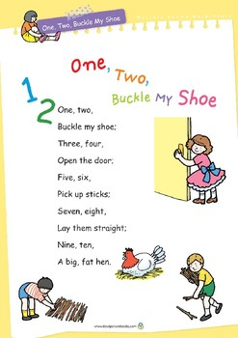
Measures: Money
Language: coin, 1 / 2 / 5 cent, euro, price, cost, buy, sell, spend, spent, pay
Monday – Make coin rubbings – 1, 2 and 5 cent coins to be used. Place coin s under a sheet of paper and rub over with a pencil to see the imprint of the coin. A fun way to introduce coins. Talk about colour, size, weight, pictures, etc.

Tuesday – Play online coin games – activity 13 and 13A http://data.cjfallon.ie/resources/19596/activity-113/index.html
14 / 14A - http://data.cjfallon.ie/resources/19596/activity-114/index2.html
Play these games using real coins

Wednesday – Play online coin games – 15 / 15A http://data.cjfallon.ie/resources/19596/activity-115/index2.html
16 / 16A - http://data.cjfallon.ie/resources/19596/activity-116/index2.html
Play these games using real coins

Thursday – Play online coin games – activity 17 / 17A http://data.cjfallon.ie/resources/19596/activity-117/index2.html
18 / 18A - http://data.cjfallon.ie/resources/19596/activity-118/index2.html
Play these games using real coins

Friday – Play online coin games – activity 19 / 19A
http://data.cjfallon.ie/resources/19596/activity-119/index2.html
20 / 20A - http://data.cjfallon.ie/resources/19596/activity-120/index2.html
Play these games using real coins
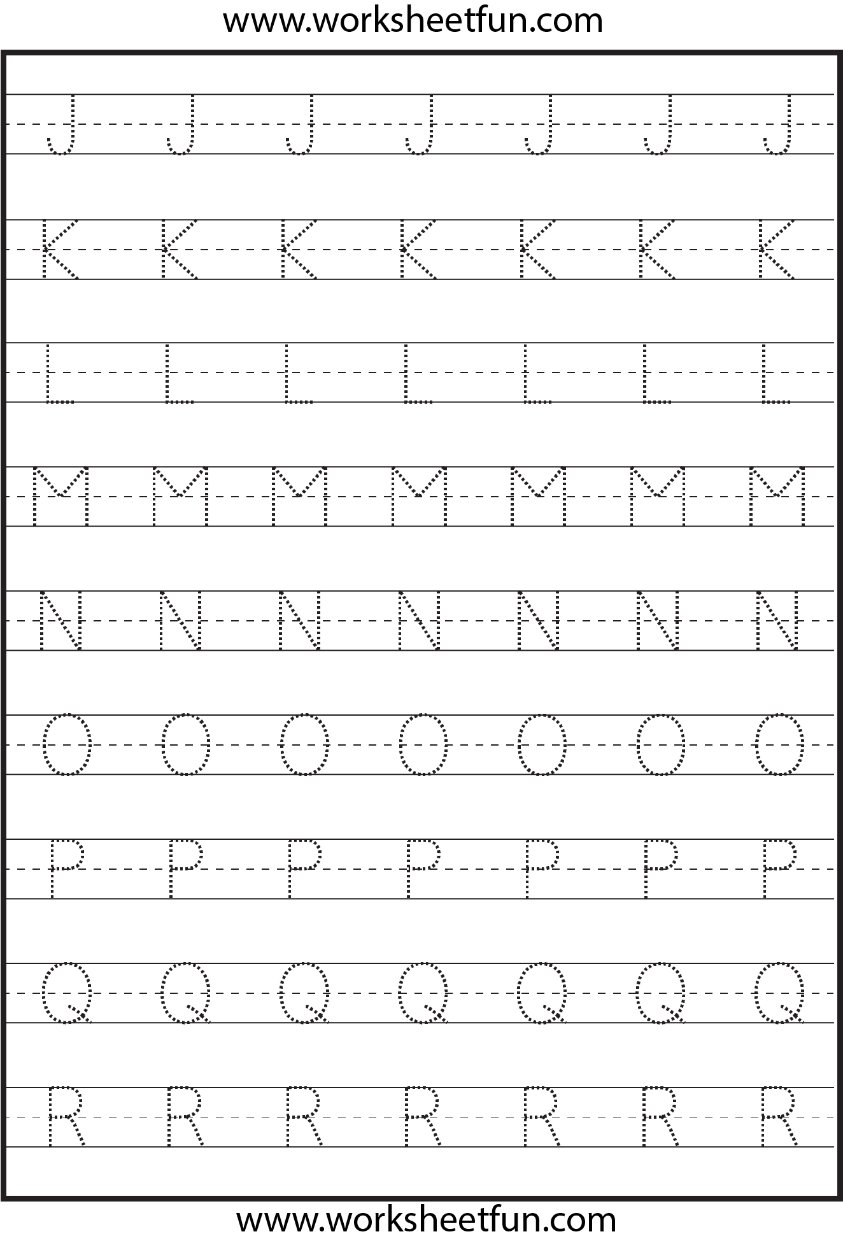
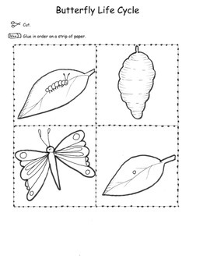
Science
Option 1– print off, colour, cut out and put in order on a strip of paper and discuss. Egg-caterpillar-cocoon-butterfly
Option 2- Draw and colour in pictures in order as above.

History
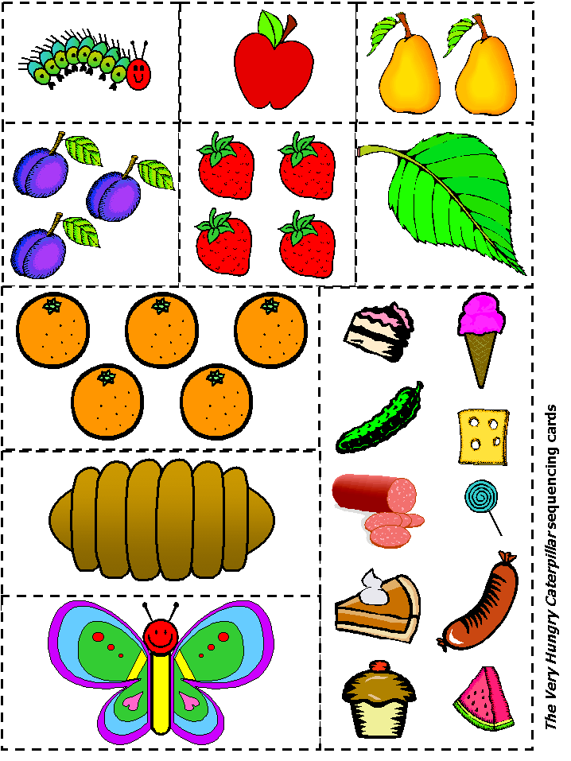
Using book or online version of story, discuss the order the story happens in. Use these pictures to help. Language - First, second, third, last. Next.
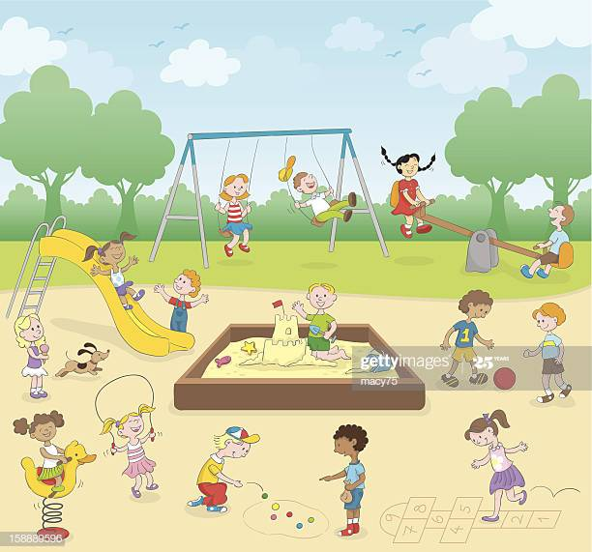
Geography
Discuss picture and a local playground you may visit.
Create your own play ground.
Ideas – water slides, zip lines, forts, pirate ship. Have at least 4 objects in your design. Let your imagination run wild!
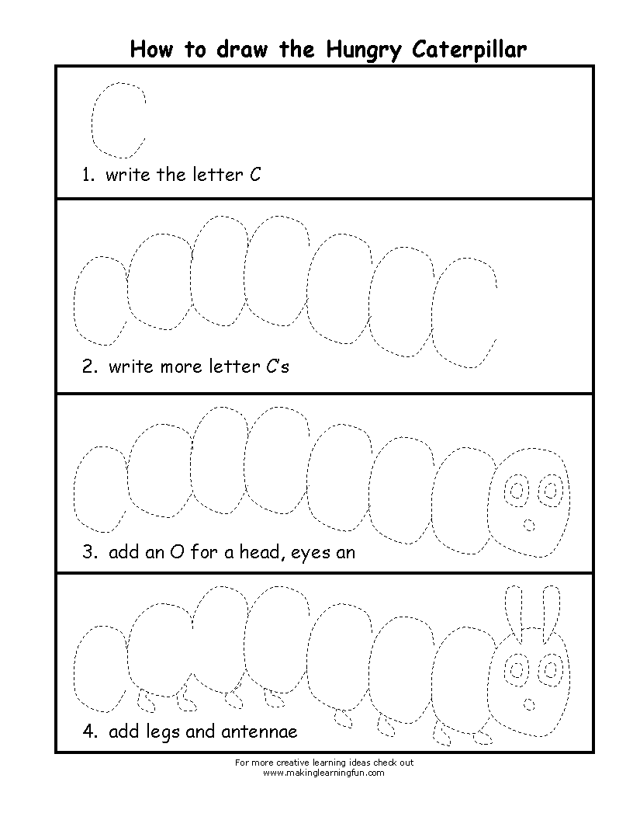
Art

