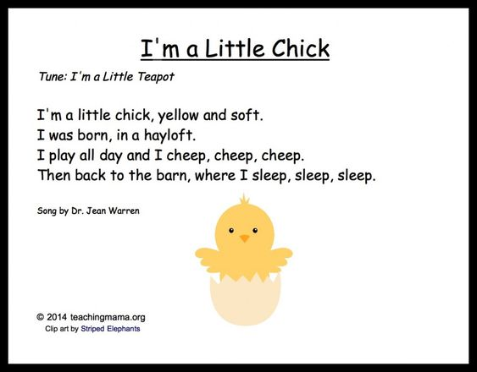
Poem

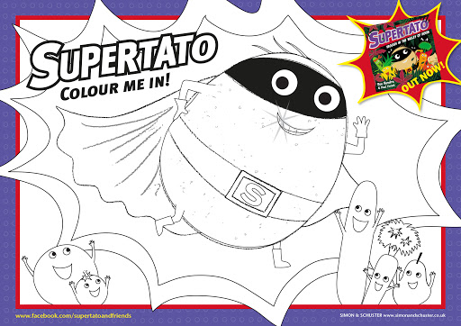
Maths
Days of the week / Number Activities

- Practice daily for the week. Write days on pieces of paper, look at what letters they start with, can they put them in order? I have added a template below you can use if you prefer. Begin at Monday. Ask questions such as how many days in the week, what comes before/after/between, what days are we in school.
Monday – Days of the Week

http://data.cjfallon.ie/resources/19596/activity-106/index.html
http://data.cjfallon.ie/resources/19596/activity-106/index2.html
Tuesday – Days of the Week

http://data.cjfallon.ie/resources/19596/activity-107/index.html
http://data.cjfallon.ie/resources/19596/activity-107/index2.html

- Make your own 4 sums after online activity using bricks/blocks. Add and write out e.g.

2 4
+ 3 + 2

Wednesday – Vertical addition within 8
http://data.cjfallon.ie/resources/19602/activity-60/index.html
http://data.cjfallon.ie/resources/19602/activity-60/index2.html
Thursday – Vertical addition within 9

http://data.cjfallon.ie/resources/19602/activity-75/index.html
http://data.cjfallon.ie/resources/19602/activity-75/index2.html
Friday – Vertical addition within 10

http://data.cjfallon.ie/resources/19602/activity-96/index.html
http://data.cjfallon.ie/resources/19602/activity-96/index2.html

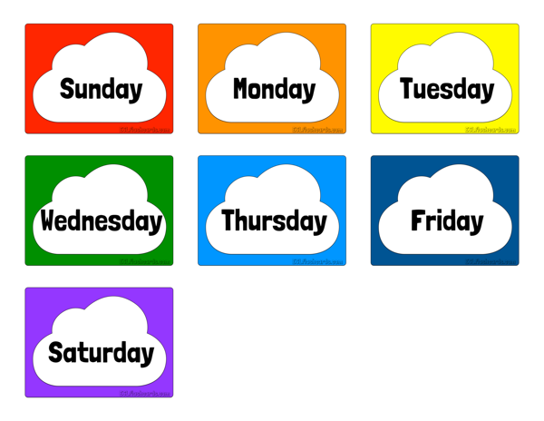
Days of the Week

Science
Farm Animal Babies
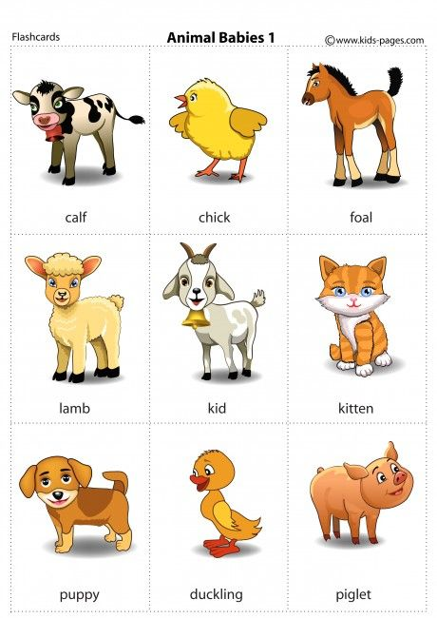
What will I be when I grow up?
S.P.H.E. – R.S.E. – Self Esteem
Story Time: Conor at School
There was once a boy called Conor. He was four. He started to go to school, just like you do. Conor loved school. He loved meeting the other children in his class and he was very fond of his teacher. He liked playing with the sand and being in the Home Corner. He liked making jigsaws and drawing pictures. He especially loved lunch time. His Mammy always packed him an apple and a yoghurt AND a sandwich. He had a carton of fruit juice to drink. Conor loved to listen to teacher when she read a story to all the boys and girls. But guess what Conor liked best of all about school? Well listen now and I'll tell you. The thing about school that Conor liked best was ... HOME TIME! I wonder why that was! When the bell rang Conor put on his warm coat and buttoned up his buttons and zipped up his zips, like his Mammy had taught him to. Then Conor lined up with the other children. When the bell rang he hurried out the door to where his Mammy and all the other Mammies and Daddies and big sisters and brothers and minders were waiting to take the children home. Everyday his Mammy would wave and call 'CONOR! CONOR! I'm over here!' Conor would hurry over to her. He'd give her a BIG hug and they would walk home. On the way home Conor used to tell his Mammy all about his day. As they reached home Conor would always say, 'What's for lunch? I'm SO hungry.' His Mammy would always reply, 'Something REALLY nice! Just wait and see!' One day at home time Conor got to the school door and ... he couldn't see his Mammy. He looked to where she usually stood and she wasn't there. He looked out towards the gate and she wasn't there either. Teacher took him by the hand and said, 'Wait here with me Conor! Your Mammy will be along in a minute!' Conor held Teacher's hand tightly. There were lots of Mammies and Daddies and big brothers and sisters and minders there, but he couldn't see his Mammy. Conor heard a voice calling 'Patrick!' Another called 'Sinéad!' Suddenly Conor heard a voice calling HIS name, 'CONOR! CONOR! It's all right. I'm over here!' It was Mammy. She was just coming in the gate. Conor called back to her, 'MAMMY! MAMMY!' He ran over to his Mammy and gave her a big hug. Mammy explained that she was late because she met Mrs. O'Brien on her way to the school and she stopped and talked to her for longer than she realised. They set off for home and he told her all about his day. As they reached home he said, 'What's for lunch? I'm so hungry!'. Mammy said, 'Something REALLY nice! Just wait and see!'
Let’s Talk:
- Conor loved going to school. What do you love to do? What do you like to do in school?
- The thing about school that Conor liked best was home time! What do you like best about school?
- On the way home Conor used to tell his Mammy all about his day. What do you talk about?
- One day at home time, Conor couldn't see his Mammy. Did this ever happen to you?
- Conor's teacher minded him until his Mammy came. Who minded you?
- At first Conor couldn't hear his Mammy calling his name. What could he hear instead?
What did Conor do when he heard his Mammy calling HIS name? Conor and his Mammy set off for home and he told her all about his day. What do you think he said to her?
Who loves you? How do they show you they love you? How do you show that you love them?
History
Tractors
Now

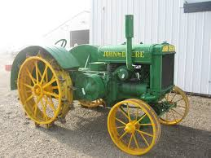
Long ago

Can you find 3 differences between the old and the new tractor?

Geography
On the Farm
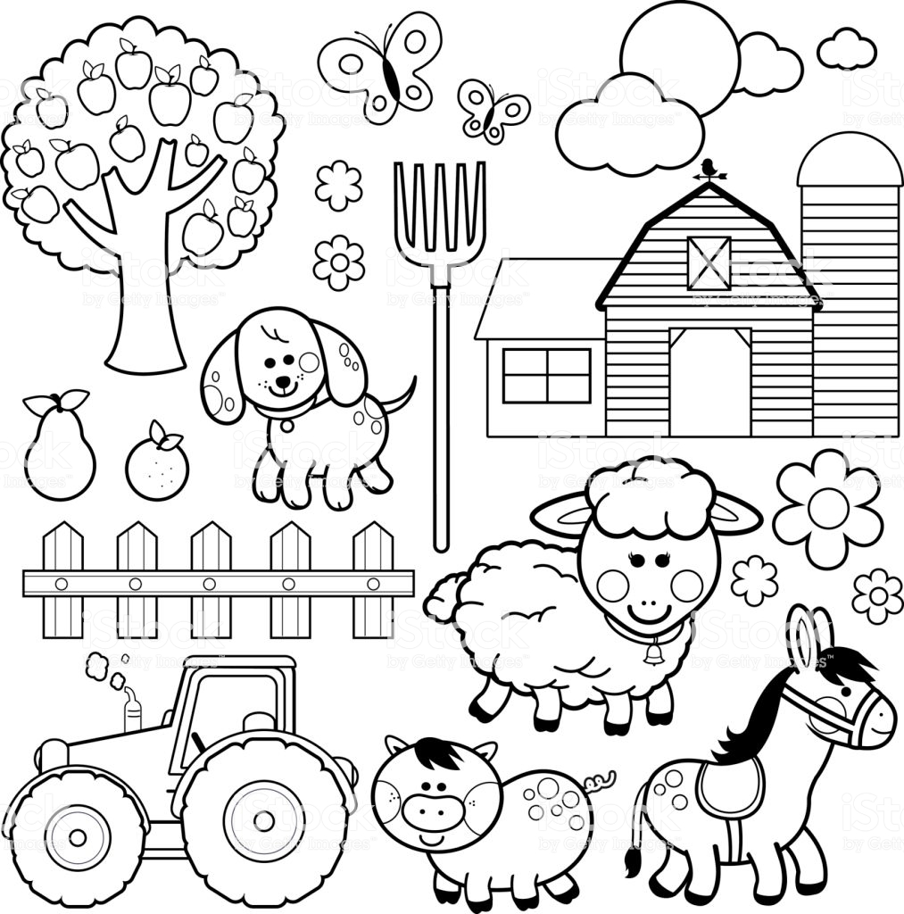
Talk about the different things you can see on the farm.

Draw a picture of the farmer.

Art
Take your Pencil for a walk
Simply start your pencil anywhere on the page and off it goes (markers are great too)!

