Elmer

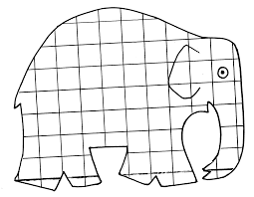
Colour in this Elmer or draw your own

Maths
Capacity
*Vocabulary to use: full, empty, holds more/less, nearly empty/full, nearly as much, container, jug.
Every day pick a practical activity to do from this list of ideas: Filling and emptying different containers with water/ sand/dirt/wood chips/pebbles/pasta/rice, etc. Use all kinds of household items to measure e.g. teaspoons/table spoons/baby formula/porridge scoops/small plastic cups, etc. Discuss how many spoons it took to fill the small flowerpot/mug, etc. Le t them come up with things to fill and empty.
Monday

http://data.cjfallon.ie/resources/19596/activity-96/index.html

http://data.cjfallon.ie/resources/19596/activity-96/index2.html

Tuesday

http://data.cjfallon.ie/resources/19596/activity-97/index.html

http://data.cjfallon.ie/resources/19596/activity-97/index2.html

Wednesday

http://data.cjfallon.ie/resources/19596/activity-98/index.html

http://data.cjfallon.ie/resources/19596/activity-98/index2.html

Thursday

http://data.cjfallon.ie/resources/19602/activity-115/index2.html

http://data.cjfallon.ie/resources/19602/activity-115/index2.html#

Writing Own Sentences

Examples of Sentences to write:
The dog is brown.
The sun is big.
The girl can jump.
The boy is happy.
Remember to making letters small, hanging and tall on the line. Use finger to make spaces between each word and put a full stop at end of each sentence.

