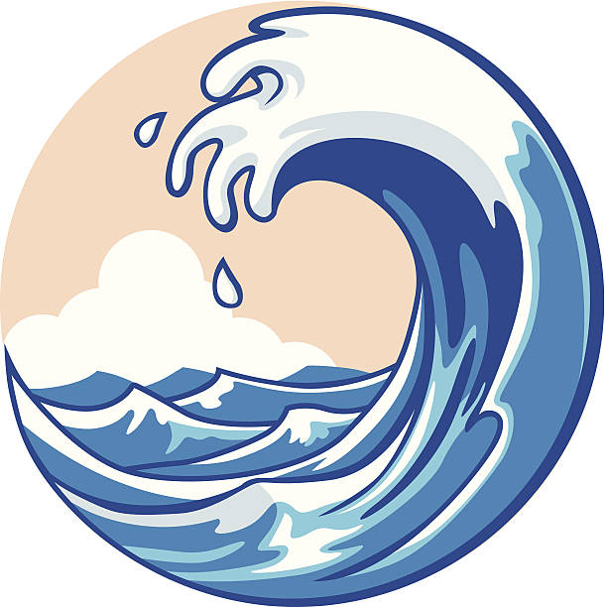
Third Class SESE 18th – 22nd May
Tsunamis
Ms. McPolin

Watch the videos and try answer these questions!
- Can you tell me something we have already learned about that causes Tsunamis?
- Where do Tsunamis happen?
- What happens to the water when there is disruption on the sea floor?
- Is the first wave of a tsunami the strongest?
- How fast can tsunamis travel?
- What is another name for a tsunami?
