The Mighty Adventures of Hamburger
Hi boys and girls,
I’ve been missing being able to tell you about the latest adventures of Hamburger so I thought I’d write you a quick message to fill you in on his latest escapades.
So recently we left him out for his hallway run around. All the doors were closed and I even put boards across the stairs to stop him from escaping upstairs to the bedrooms!! Safe as houses....or so I thought! Silly Mr. Kelliher went to the kitchen and forgot to close the door. Hamburger saw his opportunity to escape and he took it. We searched and we listened but we could not find him anywhere. Eventually we went to bed hoping he’d have found his way back to his cage by morning.
He often does find his way back....but not this time. The next morning there was neither sight nor sound of Hamburger and we were becoming increasingly worried about our little furry friend. Normally when he goes missing we can hear him rustling somewhere and that was what was worrying us most. We spent the morning and the afternoon cleaning out corners, checking behind radiators and under presses. No gnaw marks, no tiny pellet poops, nothing! It was time to take out the drill and take off the kick boards in the kitchen again. Low and behold there he was after raiding the food bin and making a nest for himself under the breakfast bar. He was disgusted we found him! He even made a strange angry hamster noise we’d never heard before. I had to capture him with an oven glove which he attacked with gusto. Eventually he found himself back in captivity lamenting his food bin nest and plotting his next escape.
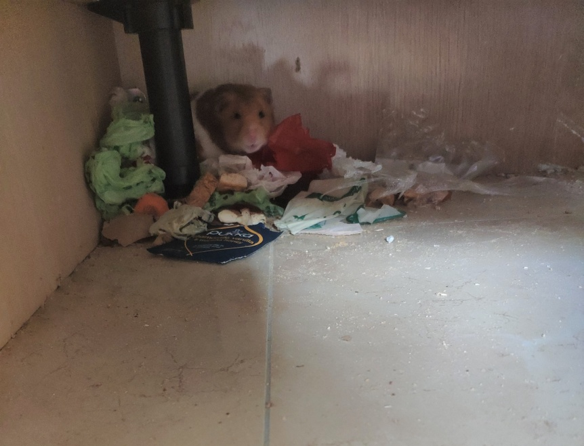
His next adventure nearly became his last. Before going to bed I had mopped the floors for 575th time since quarantine. I left the mop and bucket in the hall, popped Hamburgers cage in to the sitting room so he wouldn’t wake us running on his wheel and went off to bed. During the night Mr. Kelliher had trouble sleeping so he went downstairs to read his book. He decided to give Hamburger a bit of a run around in the hall. As he sat reading in the sitting room he heard an unusual sound. A “sploosh” followed by what sounded like someone washing their hands. He rushed out to the hallway and there was poor Hamburger frantically splashing about in the mop bucket. He scooped him out immediately. He was clearly in shock and shivering with the cold. Mr K brought him to the downstairs toilet and washed him carefully with warm water trying to heat him up and remove the cleaning chemicals that would have been in the mop bucket. Then he tried in vain to dry him with some kitchen paper. He was still wet and cold. So Mr Kelliher decided to light the fire. He put Hamburgers cage near it and the little guy paced around and around in the warmth while he dried off. He is still alive this morning and we can only hope he won’t start hiccupping bubbles!! I’m really hoping this will teach him to be a good little hamster and keep to his designated play areas!! Wish me luck!

