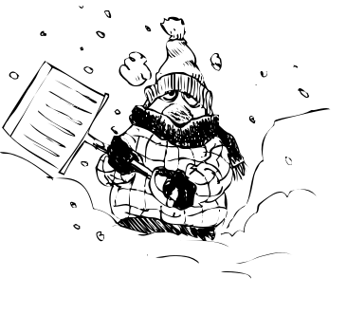

08th – 12th June
Third Class SESE
Blizzards
Ms. McPolin

- When do blizzards happen? What time of the year?
- What should you not do during a blizzard that could be dangerous?
- Does it have to be snowing for a blizzard to occur?
- What is it called when a blizzard makes it very hard to see in front of you?
- What year did the worst blizzard recorded occur? How long did it last?
- What two kinds of air have to meet to form a blizzard?
- What is snow made of?
- What three things are needed for a snow-storm to be classified as a blizzard?
- Do blizzards have to have lots of snow?

