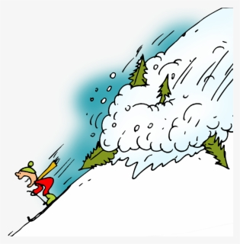

15th – 19th June
Third Class SESE
Avalanches and Landslides
Ms. McPolin

- Will shouting loudly cause an avalanche?
- What can cause an avalanche?
  - A huge amount of ________ falling in a short time
  - A person ________ on it.
- What is one of the biggest causes of an avalanche?
- What tiny particles can make snow very slippery?
- How fast can a wet avalanches travel?
- What does the word momentum mean?
- What are landslides also known as?
  - L_________
  - M_________
- What can cause landslides?
- Whatever is u____ has to come d______ due to g______.
- True or False…
Landslides can happen on flat land?
- Where shouldn’t you build houses?

